December 2025

12/12/25 - Previous work (before Reflective Portfolio creation)
- The goal is to model a snakes and ladder game using Object-Oriented Programming (OOP) in order to analyse the probability of reaching each square for a given snakes and ladder board.
- Did some basic research online about OOP and its implementation in Python.
- Created class diagrams of the project to plan it out using draw.io.
  - First diagram (with connections modelled as classes):
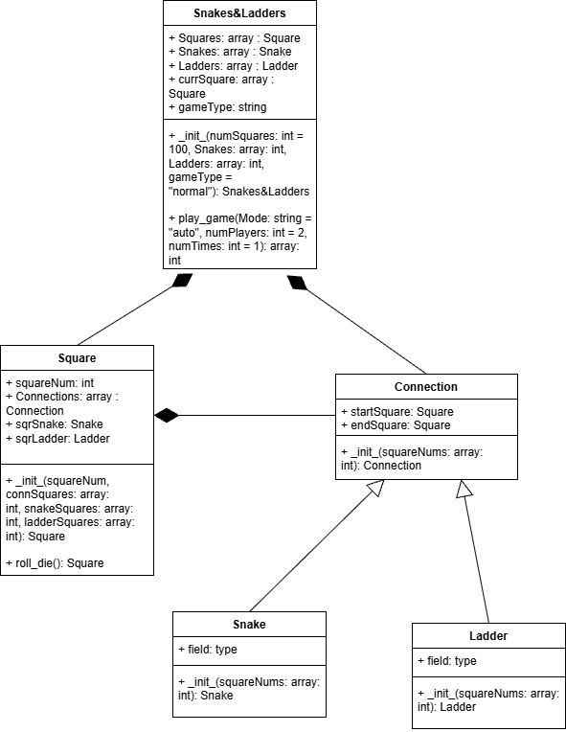
  - Second diagram (without connections modelled):
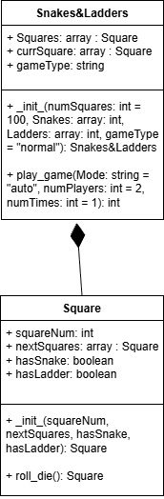
  - Went with second option due to less work and there being no apparent need to model the snakes and ladders (and more generally the connection between squares) explicitly as classes, because they don’t need to store any information or functions.
- Started work on implementation in Python.
  - Focused on Square class, which is almost finished.
    - Finished __init__() method (for when object is created from class, e.g. a = Square(squareNum=1, nextSquares=None, hasSnake=True, hasLadder=False) ) and tested inputs to make sure that it works:
def __init__(self, squareNum, nextSquares=None, hasSnake=False, hasLadder=False):
## Sets square attributes when it is created

## Inputs
## squareNum: the number of the square
## nextSquares: the list/ndarray of the numbers of the squares that can be reached by this square
## hasSnake = True (has a snake) if square is on the top of a snake
## hasLadder = True (has a ladder) if square is on the bottom of a ladder

## Outputs
## [No Outputs]

if type(squareNum) == int:
self.squareNum = squareNum
else:
print("The given square number isn't an integer, so it is set to zero.")
self.squareNum = 0

if (type(nextSquares) == 'NoneType') or (np.size(nextSquares) == 0): ## Square has no following squares (nextSquares is None) but also a snake/ladder
if (hasSnake == True) and (hasLadder == False):
print("Square",self.squareNum,"can't have a snake as it has no following squares, so it is removed.")
elif (hasSnake == False) and (hasLadder == True):
print("Square",self.squareNum,"can't have a ladder as it has no following squares, so it is removed.")
elif (hasSnake == True) and (hasLadder == True):
print("Square",self.squareNum,"can't have a snake or ladder as it has no following squares, so both are removed.")

self.hasSnake = False
self.hasLadder = False

elif (hasSnake == True) and (hasLadder == True): ## Square has both a snake and ladder
print("Square",self.squareNum,"can't have both snakes and ladders, so it will have neither.")

self.nextSquares = nextSquares
self.hasSnake = False
self.hasLadder = False

elif ((hasSnake == True) or (hasLadder == True)) and (np.size(nextSquares) > 1):
## If there is a snake/ladder and more than one following square
print("Square",self.squareNum,"has a snake/ladder, so it should have only one following square.")

self.hasSnake = hasSnake
self.hasLadder = hasLadder

for i in nextSquares:
if ((hasSnake == True) and (i < squareNum)) or ((hasLadder == True) and (i > squareNum)):
#### If next square in list is on the bottom of a snake or the top of a ladder (whichever is applicable)
if self.hasSnake == True:
print(f"Valid nextSquares number found ({i}) for square {self.squareNum} (with snake). Setting nextSquares to it")
elif self.hasLadder == True:
print(f"Valid nextSquares number found ({i}) for square {self.squareNum} (with ladder). Setting nextSquares to it")

self.nextSquares = i
break
else:
print("Warning: Square",self.squareNum,"has no valid following squares, so none will be selected.")
self.nextSquares = None

else: ### Default case
self.hasSnake = hasSnake
self.hasLadder = hasLadder
self.nextSquares = nextSquares

# Testing
## 1. Squares Class
### 1.1 __init__ (Definition and assignment)
#### 1.1.1 squareNum assignment test
print("\n \t","squareNum assignment test")
sqr1_1_1_1 = Square(squareNum=1)
print("Square 1:",sqr1_1_1_1.squareNum,"\n")

sqr1_1_1_2 = Square(squareNum="a")
print("Square 2:",sqr1_1_1_2.squareNum,"\n")

#### 1.1.2 No nextSquares with snake/ladder test
print("\n \t","No nextSquares with snake/ladder test")
sqr1_1_2_1 = Square(squareNum=1, nextSquares=None, hasSnake=True, hasLadder=False)
print(f"Square 1: hasSnake = {sqr1_1_2_1.hasSnake}, hasLadder = {sqr1_1_2_1.hasLadder} \n")
sqr1_1_2_2 = Square(squareNum=2, nextSquares=None, hasSnake=False, hasLadder=True)
print(f"Square 2: hasSnake = {sqr1_1_2_2.hasSnake}, hasLadder = {sqr1_1_2_2.hasLadder} \n")
sqr1_1_2_3 = Square(squareNum=3, nextSquares=None, hasSnake=True, hasLadder=True)
print(f"Square 3: hasSnake = {sqr1_1_2_3.hasSnake}, hasLadder = {sqr1_1_2_3.hasLadder} \n")

sqr1_1_2_4 = Square(squareNum=4, nextSquares=[], hasSnake=True, hasLadder=False)
print(f"Square 4: hasSnake = {sqr1_1_2_4.hasSnake}, hasLadder = {sqr1_1_2_4.hasLadder} \n")
sqr1_1_2_5 = Square(squareNum=5, nextSquares=[], hasSnake=False, hasLadder=True)
print(f"Square 5: hasSnake = {sqr1_1_2_5.hasSnake}, hasLadder = {sqr1_1_2_5.hasLadder} \n")
sqr1_1_2_6 = Square(squareNum=6, nextSquares=[], hasSnake=True, hasLadder=True)
print(f"Square 6: hasSnake = {sqr1_1_2_6.hasSnake}, hasLadder = {sqr1_1_2_6.hasLadder} \n")

sqr1_1_2_7 = Square(squareNum=7, nextSquares=np.array([]), hasSnake=True, hasLadder=False)
print(f"Square 7: hasSnake = {sqr1_1_2_7.hasSnake}, hasLadder = {sqr1_1_2_7.hasLadder} \n")
sqr1_1_2_8 = Square(squareNum=8, nextSquares=np.array([]), hasSnake=False, hasLadder=True)
print(f"Square 8: hasSnake = {sqr1_1_2_8.hasSnake}, hasLadder = {sqr1_1_2_8.hasLadder} \n")
sqr1_1_2_9 = Square(squareNum=9, nextSquares=np.array([]), hasSnake=True, hasLadder=True)
print(f"Square 9: hasSnake = {sqr1_1_2_9.hasSnake}, hasLadder = {sqr1_1_2_9.hasLadder} \n")

#### 1.1.3 Both snake and ladder test
print("\n \t","Both snake and ladder test")
sqr1_1_3_1 = Square(squareNum=1, nextSquares=2, hasSnake=True, hasLadder=True)
print(f"Square 1: hasSnake = {sqr1_1_3_1.hasSnake}, hasLadder = {sqr1_1_3_1.hasLadder} \n")

#### 1.1.4 Multiple following squares with a snake/ladder test
print("\n \t","Multiple following squares with a snake/ladder test")
sqr1_1_4_1 = Square(squareNum=2, nextSquares=[1,3], hasSnake=True, hasLadder=False)
print(f"Square 1: nextSquares = {sqr1_1_4_1.nextSquares} \n")
sqr1_1_4_2 = Square(squareNum=2, nextSquares=[1,3], hasSnake=False, hasLadder=True)
print(f"Square 2: nextSquares = {sqr1_1_4_2.nextSquares} \n")
sqr1_1_4_3 = Square(squareNum=1, nextSquares=[2,3], hasSnake=True, hasLadder=False)
print(f"Square 3: nextSquares = {sqr1_1_4_3.nextSquares} \n")
sqr1_1_4_4 = Square(squareNum=3, nextSquares=[1,2], hasSnake=False, hasLadder=True)
print(f"Square 4: nextSquares = {sqr1_1_4_4.nextSquares} \n")

sqr1_1_4_5 = Square(squareNum=2, nextSquares=np.array([1,3]), hasSnake=True, hasLadder=False)
print(f"Square 5: nextSquares = {sqr1_1_4_5.nextSquares} \n")
sqr1_1_4_6 = Square(squareNum=2, nextSquares=np.array([1,3]), hasSnake=False, hasLadder=True)
print(f"Square 6: nextSquares = {sqr1_1_4_6.nextSquares} \n")
sqr1_1_4_7 = Square(squareNum=1, nextSquares=np.array([2,3]), hasSnake=True, hasLadder=False)
print(f"Square 7: nextSquares = {sqr1_1_4_7.nextSquares} \n")
sqr1_1_4_8 = Square(squareNum=3, nextSquares=np.array([1,2]), hasSnake=False, hasLadder=True)
print(f"Square 8: nextSquares = {sqr1_1_4_8.nextSquares} \n")
      - Worked on it on and off over the course of a few months due to not focusing on project, hence writing reflective portfolio to set deadlines and categorise work.
      - Can make the method check that the lists/ndarray in nextSquares are one dimensional, but won’t do so unless necessary due to wanting to move on to more important parts.
    - Written roll_die() method (for getting a random square that can be reached from the current), but haven’t tested it:
def roll_die(self):
## Gets random square that can be reached from current square

## Inputs
## [No Inputs]

## Output
## Next: the number/ID of a random square following this one (False if there is no next square available)

match self:

case Square(nextSquares=None)|Square(nextSquares=[])|Square(nextSquares=np.array([])): ### If there are no squares after this one
print("Square",self.squareNum,"has no connections.")
return False

case _: ### Anything else
Next = rd.choice(self.nextSquares) ## Gets random square from nextSquares list
return Next
  - Written skeleton framework for SnakesAndLadders class, with methods that don’t do anything as a placeholder:
class SnakesAndLadders:
# Implements a Snake and Ladder Game

def _init_(self, numSquares, Snakes, Ladders, gameType):
# Defines game when it is created
return 0

def play_game(self, Mode, numPlayers, numTimes):
# Plays one/several game(s)
return 0

- The plan:
  - Finish creating/testing roll_die() method in Squares class by Monday (15/12/25).

15/12/25
- Changed __init__() in Square class to assign self.nextSquares = None when it finds out that it has no following squares, as it previously didn’t assign anything to it and thus didn’t create the attribute for the class (red highlight is changes):
if (type(nextSquares) == 'NoneType') or (np.size(nextSquares) == 0): ## Square has no following squares
### Checks if it has a snake/ladder
if (hasSnake == True) and (hasLadder == False):
print("Square",self.squareNum,"can't have a snake as it has no following squares, so it is removed.")
elif (hasSnake == False) and (hasLadder == True):
print("Square",self.squareNum,"can't have a ladder as it has no following squares, so it is removed.")
elif (hasSnake == True) and (hasLadder == True):
print("Square",self.squareNum,"can't have a snake or ladder as it has no following squares, so both are removed.")

self.hasSnake = False
self.hasLadder = False
self.nextSquares = None
  - In hindsight, I should have tested some ‘common’ object calls for Square, to make sure that it properly stores the attributes, but I plan to focus on working on other things due to being sidetracked.
- Added full stops to some messages in _init_():
for i in nextSquares:
if ((hasSnake == True) and (i < squareNum)) or ((hasLadder == True) and (i > squareNum)):
#### If next square in list is on the bottom of a snake or the top of a ladder (whichever is applicable)
if self.hasSnake == True:
print(f"Valid nextSquares number found ({i}) for square {self.squareNum} (with snake). Setting nextSquares to it.")
elif self.hasLadder == True:
print(f"Valid nextSquares number found ({i}) for square {self.squareNum} (with ladder). Setting nextSquares to it.")

self.nextSquares = i
break
- Changed roll_die() to only check nextSquares = None, to avoid a conflict with nextSquares = np.array([]) (TypeError: called match pattern must be a class), and the first change to _init_() should mean that all empty lists for nextSquares are changed to None:
match self:

case Square(nextSquares=None): ### If there are no squares after this one
print("Square",self.squareNum,"has no connections.")
return False

case _: ### Anything else
Next = rd.choice(self.nextSquares) ## Gets random square from nextSquares list
return Next
- Completed the testing for roll_die():
### 1.2 roll_die function
print("\n \t","roll_die test")
sqr1_2_1 = Square(squareNum=1, nextSquares=None)
next_1 = sqr1_2_1.roll_die()
print(f"Square 1: Next square: {next_1}\n")

sqr1_2_2 = Square(squareNum=2, nextSquares=[])
next_2 = sqr1_2_2.roll_die()
print(f"Square 2: Next square: {next_2}\n")

sqr1_2_3 = Square(squareNum=3, nextSquares=np.array([]))
next_3 = sqr1_2_3.roll_die()
print(f"Square 3: Next square: {next_3}\n")

sqr1_2_4 = Square(squareNum=4, nextSquares=[6,7,8,9,10])
next_4 = sqr1_2_4.roll_die()
print(f"Square 4: Next square: {next_4}\n")

sqr1_2_5 = Square(squareNum=5, nextSquares=[6,7,8,9,10])
next_5 = sqr1_2_5.roll_die()
print(f"Square 5: Next square: {next_5}\n")
- The plan:
  - Start working on __init__() method for the SnakesAndLadders class and try to start testing by Friday (19/12/25).

19/12/25
- Couldn’t work on project due to issues with importing NumPy, trying to solve it by reinstalling Anaconda.
- The plan:
  - Try to solve issue and continue working on project by Monday (22/12/25).

23/12/25
- Missed my previous deadline.
- Added description comments to the placeholder class:
class SnakesAndLadders:
# Implements a Snake and Ladder Game

def _init_(self, numSquares, Snakes, Ladders, Overflow):
## Defines game when it is created

## Inputs
## numSquares: the number of squares on the board
## Snakes: the 2D list/ndarray containing the start and end square for every snake
## Ladders: the 2D list/ndarray containing the start and end square for every ladder
## Overflow: What to do if the rolled square is beyond the last on the board. 'classic': overflows count as last; 'rollback': overflows are subtracted from last; 'ignore': overflows aren't counted

## Outputs
## [No Outputs]

return 0
- The Plan:
  - Continue working on __init__() method for the SnakesAndLadders class tomorrow (24/12/25).

25/12/25
- Missed my deadline again.
- Added a comment to Square’s _init_() method:
def __init__(self, squareNum, nextSquares=None, hasSnake=False, hasLadder=False):
## Sets square attributes when it is created

## Inputs
## squareNum: the number of the square
## nextSquares: the list/ndarray of the numbers of the squares that can be reached by this square
## hasSnake = True (has a snake) if square is on the top of a snake
## hasLadder = True (has a ladder) if square is on the bottom of a ladder

## Outputs
## [No Outputs]

## Makes sure that squareNum is the correct type
if type(squareNum) == int:
self.squareNum = squareNum
else:
print("The given square number isn't an integer, so it is set to zero.")
self.squareNum = 0
- Created first draft for SnakesAndLadders’s __init__() method, but haven’t tested it yet:
def _init_(self, numSquares, Snakes, Ladders, Overflow):
## Defines game when it is created

## Inputs
## numSquares: the number of squares on the board
## Snakes: the 2D list/ndarray containing the start and end square for every snake
## Ladders: the 2D list/ndarray containing the start and end square for every ladder
## Overflow: What to do if the rolled square is beyond the last on the board. 'classic': overflows count as last square; 'rollback': overflows are subtracted from last; 'ignore': overflows aren't counted

## Outputs
## [No Outputs]

## Makes sure that numSquares is the correct type
if type(numSquares) == int:
self.numSquares = numSquares
else:
print("The given numbers of squares isn't an integer, so it is set to 100.")
self.numSquares = 100

## Stores other parameters as attributes
self.Snakes = Snakes
self.Ladders = Ladders
self.Overflow = Overflow

## Predefines list of squares
self.Squares = []

for i in range(0, self.numSquares - 1):
### Predefines Square parameters
sqrNum = i+1
nxtSqrs = None
hsSnk = False
hsLdr = False

### Checks if the square has a snake
for s in Snakes:
if sqrNum in s:
nxtSqrs = s.remove(sqrNum)
hsSnk = True
break

### Checks if the square has a ladder
for l in Ladders:
if sqrNum in l:
nxtSqrs = l.remove(sqrNum)
hsLdr = True
break

### Sets nxtSqrs (nextSquares) if the square doesn't have a snake/ladder
if nxtSqrs == None:
nxtSqrs = [i+1, i+2, i+3, i+4, i+5, i+6]

### Creates square and adds it to the list
square = Square(squareNum=sqrNum, nextSquares=nxtSqrs, hasSnake=hsSnk, hasLadder=hsLdr)
self.Squares.append(square)
- The Plan:
  - Try to finish first draft for SnakesAndLadders’s __init__() method, and start testing by Monday (29/12/25).

29/12/25
- Changed testing comment for Square class for clarity:
# Testing
## 1. Squares Class
### 1.1 __init__ function (Definition and assignment)
- Changed SnakesAndLadders’s __init__() method to use attributes instead of parameters for Snake and Ladder lists, so invalid parameters could be changed (in later changes), as well as add conditions for if the last square are in the lists:
### Checks if the square has a snake
for s in self.Snakes:
if sqrNum in s:
if sqrNum == self.numSquares:
print("The last square can't have a snake.")
else:
nxtSqrs = s.remove(sqrNum)
hsSnk = True
break

### Checks if the square has a ladder
for l in self.Ladders:
if sqrNum in l:
if sqrNum == self.numSquares:
print("The last square can't have a snake.")
else:
nxtSqrs = l.remove(sqrNum)
hsLdr = True
break

- Changed same method’s nxtSqrs assignment at the end to account for Overflow value:
### Sets nxtSqrs (nextSquares) if the square doesn't have a snake/ladder
if nxtSqrs == None:
if sqrNum == self.numSquares:
break ##### nxtSqrs is still None
elif (self.numSquares - 6) < sqrNum < self.numSquares: #### 5th last to penultimate squares
match self.Overflow:
case 'classic'|'Classic'|'c'|'C'|'ignore'|'Ignore'|'i'|'I': ###### Both 'classic' and 'ignore'
nxtSqrs = np.arange(sqrNum + 1, sqrNum + 7) ####### NP array with next 6 square numbers from current
case 'rollback'|'Rollback'|'r'|'R':
nxtSqrs = np.arange(self.numSquares - 5, self.numSquares + 1) ####### NP array with last 6 square numbers from end
else:
nxtSqrs = np.arange(sqrNum + 1, sqrNum + 7)
- Started testing of SnakesAndLadders’s __init__() method:
## 2. SnakesAndLadders Class
### 2.1 __init__ function (Definition and assignment)
#### 2.1.1 Default square creation testing
print("\n \t","squareNum assignment test")
slg2_1_1_1 = SnakesAndLadders(numSquares=10, Snakes=[], Ladders=[], Overflow='classic')
sqrList2_1_1_1 = slg2_1_1_1.Squares
print("Snakes and Ladder game:")
print(f"Number of squares: {len(sqrList2_1_1_1)}, squares: {sqrList2_1_1_1}\n")

sqr2_1_1_1 = sqrList2_1_1_1[0]
print("1st square:")
print(f"Square number: {sqr2_1_1_1.squareNum}, next squares: {sqr2_1_1_1.nextSquares}\n")

sqr2_1_1_2 = sqrList2_1_1_1[4]
print("2nd square:")
print(f"Square number: {sqr2_1_1_2.squareNum}, next squares: {sqr2_1_1_2.nextSquares}\n")

sqr2_1_1_3 = sqrList2_1_1_1[9]
print("3rd square:")
print(f"Square number: {sqr2_1_1_3.squareNum}, next squares: {sqr2_1_1_3.nextSquares}\n")
- The plan:
  - Continue working on SnakesAndLadders’s __init__() method and its tests by Friday (02/01/26).

January 2026

02/01/26
- For SnakesAndLadders’s __init__() method, corrected mistake in has ladder check code:
### Checks if the square has a ladder
for l in self.Ladders:
if sqrNum in l:
if sqrNum == self.numSquares:
print("The last square can't have a ladder.")
else:
nxtSqrs = l.remove(sqrNum)
hsLdr = True
break
- Added a function to check the Snakes and Ladders lists to see if they are the correct shape (have the correct amount of dimensions) and replaced attributes assignment with it:
def check_snake_ladder_shape(snkOrLddr, name):
### Checks the shape (dimensions) of the Snakes or Ladders list, and replaces it if it isn't the correct type

### Inputs
### snkOrLddr: the Snakes or Ladders list/ndarray to be checked
### name: the name of the Snakes or Ladders list/ndarray, for the warning messages

### Outputs
### newSnkOrLddr: the checked or changed Snakes or Ladders list/ndarray, for assignment into the attributes

match np.shape(snkOrLddr): ### Matches the dimensions of the list
case (n, 2): #### Correct shape
newSnkOrLddr = snkOrLddr
case (2, n): #### Transposed shape
print(f"The {name} array should have a n by 2 shape, where n is the number of {name}. Therefore, it is reshaped.")
newSnkOrLddr = np.reshape(snkOrLddr, (n, 2))
case (n, m): #### Wrong dimensions
print(f"The {name} array should have a n by 2 shape, where n is the number of {name}. Therefore, replaced with empty list.")
newSnkOrLddr = []
case _: #### Not a list
print(f"{name} should be an (n by 2) array, where n is the number of {name}. Therefore, replaced with empty list.")
newSnkOrLddr = []

return newSnkOrLddr

## Stores other parameters as attributes
self.Snakes = check_snake_ladder_shape(Snakes, "snakes")
self.Ladders = check_snake_ladder_shape(Ladders, "ladders")
self.Overflow = Overflow
- The plan:
  - Continue working on SnakesAndLadders’s __init__() method and its tests by Monday (05/01/26).

06/01/26
- Missed my previous deadline.
- Added some lines to the first of SnakesAndLadders’s __init__() method tests, to test non-integer numSquares values are handled correctly (new line print commands also added for clarity during test):
## 2. SnakesAndLadders Class
### 2.1 __init__ function (Definition and assignment)
#### 2.1.1 Default square creation testing
print("\n \t","squareNum assignment test")
slg2_1_1_1 = SnakesAndLadders(numSquares=10, Snakes=[], Ladders=[], Overflow='classic')
print('\n')
slg2_1_1_2 = SnakesAndLadders(numSquares=10.5, Snakes=[], Ladders=[], Overflow='classic')
print('\n')
slg2_1_1_3 = SnakesAndLadders(numSquares="10", Snakes=[], Ladders=[], Overflow='classic')
print('\n')
- As testing showed that empty Snakes and Ladders lists were treated like the ‘not a list’ option, they (empty 1D and 2D lists) were given their own case, being assigned an empty (1D) list with no warning message. Also changed the comment for the last option for clarity:
match np.shape(snkOrLddr): ### Matches the dimensions of the list
case (n, 2): #### Correct shape
newSnkOrLddr = snkOrLddr
case (2, n): #### Transposed shape
print(f"The {name} array should have a n by 2 shape, where n is the number of {name}. Therefore, it is reshaped.")
newSnkOrLddr = np.reshape(snkOrLddr, (n, 2))
case (n, m): #### Wrong dimensions
print(f"The {name} array should have a n by 2 shape, where n is the number of {name}. Therefore, replaced with empty list.")
newSnkOrLddr = []
case (0,)|(1,0): #### Empty 1D or 2D list respectively
newSnkOrLddr = []
case _: #### Not a (2D) list
print(f"{name} should be an (n by 2) array, where n is the number of {name}. Therefore, replaced with empty list.")
newSnkOrLddr = []
- Changed most warning messages in both SnakesAndLadders and Square classes to be clear that they are warnings. For example:
## Makes sure that numSquares is the correct type
if type(numSquares) == int:
self.numSquares = numSquares
else:
print("WARNING: The given numbers of squares isn't an integer, so it is set to 100.")
self.numSquares = 100
- Started testing handling of snakes and ladders list:
#### 2.1.2 Snakes and Ladders lists test
print("\n \t","Snakes and Ladders lists test")
##### 2.1.2.1 Correct format test
print("\n \t \t","Correct format test")
slg2_1_2_1_1 = SnakesAndLadders(numSquares=10, Snakes=[[9,2],[7,5]], Ladders=[[3,10],[4,6]], Overflow='classic')
print(f"Snakes: {slg2_1_2_1_1.Snakes}; Ladders: {slg2_1_2_1_1.Ladders}\n")

print("Squares:")
for i in slg2_1_2_1_1.Squares:
print(f"Square number: {i.squareNum}, next squares: {i.nextSquares}\n")
  - Initial running of test lead to issues:
Snakes and Ladders lists test

Correct format test
WARNING: Square 2 has a snake/ladder, so it should have only one following square.
WARNING: Square 2 has no valid following squares, so none will be selected.
WARNING: Square 3 has a snake/ladder, so it should have only one following square.
Valid nextSquares number found (4) for square 3 (with ladder). Setting nextSquares to it.
WARNING: Square 4 has a snake/ladder, so it should have only one following square.
Valid nextSquares number found (5) for square 4 (with ladder). Setting nextSquares to it.
WARNING: Square 5 has a snake/ladder, so it should have only one following square.
WARNING: Square 5 has no valid following squares, so none will be selected.
WARNING: Square 6 has a snake/ladder, so it should have only one following square.
Valid nextSquares number found (7) for square 6 (with ladder). Setting nextSquares to it.
WARNING: Square 7 has a snake/ladder, so it should have only one following square.
WARNING: Square 7 has no valid following squares, so none will be selected.
WARNING: Square 9 has a snake/ladder, so it should have only one following square.
WARNING: Square 9 has no valid following squares, so none will be selected.
WARNING: The last square can't have a ladder.
Snakes: [[], []], Ladders: [[10], []]

Squares:
Square number: 1, next squares: [2 3 4 5 6 7]

Square number: 2, next squares: None

Square number: 3, next squares: 4

Square number: 4, next squares: 5

Square number: 5, next squares: None

Square number: 6, next squares: 7

Square number: 7, next squares: None

Square number: 8, next squares: [ 9 10 11 12 13 14]

Square number: 9, next squares: None

Square number: 10, next squares: None
- The plan:
  - Try to get SnakesAndLadders’s __init__() method working with correctly formatted Snakes and Ladders lists by Friday (09/01/26)

09/01/26
- Solved previous issue with SnakesAndLadders’s __init__() method by making code detect and assign each ‘snake’s’/’ladder ’s’ maximum and minimum values. This should also have the benefit of not being reliant on number order:
### Checks if the square has a snake
for s in self.Snakes:
if sqrNum == np.max(s):
if sqrNum == self.numSquares:
print("WARNING: The last square can't have a snake.")
else:
nxtSqrs = np.min(s)
hsSnk = True
break

### Checks if the square has a ladder
for l in self.Ladders:
if sqrNum == np.min(l):
if sqrNum == self.numSquares:
print("WARNING: The last square can't have a ladder.")
else:
nxtSqrs = np.max(l)
hsLdr = True
break
- Also added some code before Square creating loop to delete ‘snakes’ from Snakes list if they are invalid:
## Predefines number for counting number of Snakes list rows, and flag for issue with 'snake'
n = 0
issue = False

## Removes 'snakes' from snakes list with invalid bound(s)
for s in self.Snakes:
issue = False

if np.min(s) < 1: ### Less than minimum
print(f"WARNING: The min. square of a snake can't be less than 1, therefore snake {s} is deleted.")
issue = True
elif np.max(s) > self.numSquares: ### More than maximum
print(f"WARNING: The max. square of a snake can't be greater than {self.numSquares}, therefore snake {s} is deleted.")
issue == True
elif np.min(s) == np.max(s): ### Same square values
print(f"WARNING: The squares of a snake can't be the same, therefore snake {s} is deleted.")
issue == True
else:
n = n + 1

if issue == True:
self.Snakes = np.delete(self.Snakes, n, 0)
  - I plan to create a function based on this for both snakes and ladders later
- The plan:
  - Complete new snakes/ladder value checking function by Monday (12/01).
  - Continue working on SnakesAndLadders’s __init__() method and its tests.

14/01/26
- Missed the previous deadline.
- Imported Types in order to use NoneTypes:
import numpy as np
import random as rd
import types as tp
- In SnakesAndLadders’s __init__() method, added modified version of previously mentioned value checking code to check_snake_ladder_shape() function, changing name to check_snake_ladder():
def check_snake_ladder(snkOrLddr, name):
### Checks the shape (dimensions) and bounds of the Snakes or Ladders list, and replaces/remove it respectively if it isn't the correct type

### Inputs
### snkOrLddr: the Snakes or Ladders list/ndarray to be checked
### name: the name of the Snakes or Ladders list/ndarray, for the warning messages

### Outputs
### newSnkOrLddr: the checked or changed Snakes or Ladders list/ndarray, for assignment into the attributes

match np.shape(snkOrLddr): ### Matches the dimensions of the list
case (n, 2): #### Correct shape
newSnkOrLddr = snkOrLddr
case (2, n): #### Transposed shape
print(f"WARNING: The {name} array should have a n by 2 shape, where n is the number of {name}. Therefore, its axes are swapped.")
newSnkOrLddr = np.swapaxes(snkOrLddr, 0, 1)
case (n, m): #### Wrong dimensions
print(f"WARNING: The {name} array should have a n by 2 shape, where n is the number of {name}. Therefore, replaced with empty list.")
newSnkOrLddr = []
case (0,)|(1,0): #### Empty 1D or 2D list respectively
newSnkOrLddr = []
case _: #### Not a (2D) list
if not isinstance(snkOrLddr, tp.NoneType): ##### If snkOrLddr is not equal to None
print(f"WARNING: {name} should be an (n by 2) array but is {type(snkOrLddr)}, where n is the number of {name}. Therefore, replaced with empty list.")
newSnkOrLddr = []

## Predefines number for counting number of Snakes list rows, and flag for invalid 'snake'
num = 0
invalid = False

### Removes 'snakes/ladders' from the list with invalid bound(s)
for nsl in newSnkOrLddr:
invalid = False

if np.min(nsl) < 1: ### Less than minimum
print(f"WARNING: A min. bound in {name} can't be less than 1, therefore bound {nsl} is deleted.")
invalid = True
elif np.max(nsl) > self.numSquares: ### More than maximum
print(f"WARNING: A max. bound in {name} can't be greater than {self.numSquares}, therefore bound {nsl} is deleted.")
invalid = True
elif np.min(nsl) == np.max(nsl): ### Same square values
print(f"WARNING: The bounds in {name} can't be the same, therefore bound {nsl} is deleted.")
invalid = True
else:
num = num + 1

if invalid == True:
newSnkOrLddr = np.delete(newSnkOrLddr, num, 0) #### Deletes bounds (row of list) if it is invalid

return newSnkOrLddr
  - Later testing showed issues in the match-case statement that were changed:
    - Initial axes swapping didn’t work.
    - Default statement was unclear and worked when the list is None.
- Created more code for testing incorrect inputs for the Snakes and Ladders lists:
##### 2.1.2.2 Correct format test
print("\n \t \t","Incorrect format test")
print("Game 1:")
slg2_1_2_2_1 = SnakesAndLadders(numSquares=20, Snakes=[[9,2],[8,0],[3,7],[21,4],[6,5],[5,5]], Ladders=[[11,13,15],[12,14,16]], Overflow='classic')
print(f"Snakes: {slg2_1_2_2_1.Snakes}; Ladders: {slg2_1_2_2_1.Ladders}\n")

print("Squares:")
for i in slg2_1_2_2_1.Squares:
print(f"Square number: {i.squareNum}, next squares: {i.nextSquares}")

print("\nGame 2:")
slg2_1_2_2_2 = SnakesAndLadders(numSquares=10, Snakes=[[10,9,8],[7,6,5],[4,3,2]], Ladders="Ladder List", Overflow='classic')
print(f"Snakes: {slg2_1_2_2_2.Snakes}; Ladders: {slg2_1_2_2_2.Ladders}\n")

print("Game 3:")
slg2_1_2_2_3 = SnakesAndLadders(numSquares=10, Snakes=[], Ladders=None, Overflow='classic')
print(f"Snakes: {slg2_1_2_2_3.Snakes}; Ladders: {slg2_1_2_2_3.Ladders}\n")
- In Square’s __init__() method, changed no following squares code to use imported NoneTypes:
if ( isinstance(nextSquares, tp.NoneType) ) or (np.size(nextSquares) == 0): ## Square has no following squares
### Checks if it has a snake/ladder
if (hasSnake == True) and (hasLadder == False):
print("WARNING: Square",self.squareNum,"can't have a snake as it has no following squares, so it is removed.")
elif (hasSnake == False) and (hasLadder == True):
print("WARNING: Square",self.squareNum,"can't have a ladder as it has no following squares, so it is removed.")
elif (hasSnake == True) and (hasLadder == True):
print("WARNING: Square",self.squareNum,"can't have a snake or ladder as it has no following squares, so both are removed.")

self.hasSnake = False
self.hasLadder = False
self.nextSquares = None
- The plan:
  - Work on testing Overflow assignment for SnakesAndLadders’s __init__() method by next Monday (19/01).

19/01/26
- Corrected comment for latest test for Snakes and Ladders list of SnakesAndLadders’s __init__() method:
##### 2.1.2.2 Incorrect format test
print("\n \t \t","Incorrect format test")
print("Game 1:")
slg2_1_2_2_1 = SnakesAndLadders(numSquares=20, Snakes=[[9,2],[8,0],[3,7],[21,4],[6,5],[5,5]], Ladders=[[11,13,15],[12,14,16]], Overflow='classic')
print(f"Snakes: {slg2_1_2_2_1.Snakes}; Ladders: {slg2_1_2_2_1.Ladders}\n")

- Added a match-case statement to check the validity of the Overflow parameter, and then assigns a relevant value to the corresponding attribute:
## Makes sure that Overflow type is valid and stores it as an attribute
try:
match Overflow.lower():
case 'classic'|'c':
self.Overflow = 'classic'
case 'rollback'|'r'|'rb':
self.Overflow = 'rollback'
case 'ignore'|'i':
self.Overflow = 'ignore'
case _: #### Invalid type
print("WARNING: Overflow is not valid. Setting to Classic.")
self.Overflow = 'classic'
except Exception as e: ## Catch any exceptions, especially AttributeError from not having lower() method
print(f"WARNING: {str(e)}, so Overflow is not valid. Setting to Classic.") ### e is the error message
self.Overflow = 'classic'

- Changed comment on previous attributes assignments:
## Stores Snakes and Ladders lists as attributes
self.Snakes = check_snake_ladder(Snakes, "snakes")
self.Ladders = check_snake_ladder(Ladders, "ladders")
- Create new tests for Overflow:
#### 2.1.3 Overflow test
print("\n \t","Overflow test")
##### 2.1.3.1 Correct format test
print("\t \t","Correct (overflow) format test")

print(f"Game 1 (classic):")
slg2_1_3_1_1 = SnakesAndLadders(numSquares=10, Snakes=[], Ladders=[], Overflow='classic')
print("Squares:")
for i in slg2_1_3_1_1.Squares[3:]:
print(f"Square number: {i.squareNum}, next squares: {i.nextSquares}")

print(f"\nGame 2 (rollback):")
slg2_1_3_1_2 = SnakesAndLadders(numSquares=10, Snakes=[], Ladders=[], Overflow='rollback')
print("Squares:")
for i in slg2_1_3_1_2.Squares[3:]:
print(f"Square number: {i.squareNum}, next squares: {i.nextSquares}")

print(f"\nGame 3 (ignore):")
slg2_1_3_1_3 = SnakesAndLadders(numSquares=10, Snakes=[], Ladders=[], Overflow='ignore')
print("Squares:")
for i in slg2_1_3_1_3.Squares[3:]:
print(f"Square number: {i.squareNum}, next squares: {i.nextSquares}")

print(f"\nGame 4 (c):")
slg2_1_3_1_4 = SnakesAndLadders(numSquares=10, Snakes=[], Ladders=[], Overflow='c')
sqr2_1_3_1_4 = slg2_1_3_1_4.Squares[8]
print(f"Square number: {sqr2_1_3_1_4.squareNum}, next squares: {sqr2_1_3_1_4.nextSquares}")

print(f"\nGame 5 (r):")
slg2_1_3_1_5 = SnakesAndLadders(numSquares=10, Snakes=[], Ladders=[], Overflow='r')
sqr2_1_3_1_5 = slg2_1_3_1_5.Squares[8]
print(f"Square number: {sqr2_1_3_1_5.squareNum}, next squares: {sqr2_1_3_1_5.nextSquares}")

print(f"\nGame 6 (rb):")
slg2_1_3_1_6 = SnakesAndLadders(numSquares=10, Snakes=[], Ladders=[], Overflow='rb')
sqr2_1_3_1_6 = slg2_1_3_1_6.Squares[8]
print(f"Square number: {sqr2_1_3_1_6.squareNum}, next squares: {sqr2_1_3_1_6.nextSquares}")

print(f"\nGame 7 (i):")
slg2_1_3_1_7 = SnakesAndLadders(numSquares=10, Snakes=[], Ladders=[], Overflow='i')
sqr2_1_3_1_7 = slg2_1_3_1_7.Squares[8]
print(f"Square number: {sqr2_1_3_1_7.squareNum}, next squares: {sqr2_1_3_1_7.nextSquares}")

print(f"\nGame 8 (ClAsSiC):")
slg2_1_3_1_8 = SnakesAndLadders(numSquares=10, Snakes=[], Ladders=[], Overflow='ClAsSiC')
sqr2_1_3_1_8 = slg2_1_3_1_8.Squares[8]
print(f"Square number: {sqr2_1_3_1_8.squareNum}, next squares: {sqr2_1_3_1_8.nextSquares}")

##### 2.1.3.2 Inorrect format test
print("\n \t \t","Incorrect (overflow) format test")
print(f"Game 1: (different string)")
slg2_1_3_2_1 = SnakesAndLadders(numSquares=10, Snakes=[], Ladders=[], Overflow='different')
print("Squares:")
for i in slg2_1_3_2_1.Squares[3:]:
print(f"Square number: {i.squareNum}, next squares: {i.nextSquares}")

print(f"\nGame 2: (integer)")
slg2_1_3_2_2 = SnakesAndLadders(numSquares=10, Snakes=[], Ladders=[], Overflow=1)

print(f"\nGame 3: (None)")
slg2_1_3_2_3 = SnakesAndLadders(numSquares=10, Snakes=[], Ladders=[], Overflow=None)
- The plan:
  - Start working on SnakesAndLadders’s play_game() method by Friday (23/01).

23/01/26
- For SnakesAndLadders’s __init__() method, added more testing for Snakes and Ladder lists for handling bounds with the last square and lists with different number of dimensions (depth):
print("Game 4:")
slg2_1_2_2_4 = SnakesAndLadders(numSquares=10, Snakes=[[9,1],[10,2]], Ladders=[[3,8],[4,10]], Overflow='classic')
print(f"Snakes: {slg2_1_2_2_4.Snakes}; Ladders: {slg2_1_2_2_4.Ladders}\n")

print("Game 5:")
slg2_1_2_2_5 = SnakesAndLadders(numSquares=12, Snakes=[1,2,3,4], Ladders=[[[3,4],[5,6]],[[7,8],[9,10]]], Overflow='classic')
print(f"Snakes: {slg2_1_2_2_5.Snakes}; Ladders: {slg2_1_2_2_5.Ladders}\n")

- Completed first draft for SnakesAndLadders’s play_game() method, but haven’t tested it yet:
def play_game(self, numPlayers, numTimes):
## Plays Snakes and Ladder game a specified number of times

## Inputs
## numPlayers: the number of players for the game(s)
## numTimes: the number of times to play the game

## Outputs
## gameSqrNums: the list of arrays containing the square number of each player for each turn of a game (starting from the zeroth turn)

for i in range(0,numTimes):
game = i + 1
turn = 0
gameEnd = False
gameSqrNums = np.ones((numPlayers,1)) ### Rows are the players, columns are the turns
gamesList = []

print(f"\n \t Game: {game} \n")

### Game loop
while gameEnd == False:
turn = turn + 1
turnSqrNums = np.empty((numPlayers,1)) ##### Predefines current turn square number array for later
firstWinner = True ##### Indicates whether the first winner has been found

print(f"\n \t \t Turn: {turn}")

#### Turn loop
for j in range(0,numPlayers):
player = j + 1
prevNum = gameSqrNums[j,turn-1]
currNum = self.Squares[prevNum-1].roll_die()

if currNum == self.numSquares: ##### Player reaches the last square
gameEnd = True

if firstWinner == True: ###### Makes sure that this is the first valid winner
winner = player
firstWinner = False

elif currNum > self.numSquares: ##### Player rolls a higher square than the last (if possible)

match self.Overflow:
case 'classic':
currNum = self.numSquares
gameEnd = True

if firstWinner == True: ######## Makes sure that this is the first valid winner
winner = player
firstWinner = False
case 'ignore':
print(f"Player {player}'s roll ({currNum}) was too big.")
currNum = gameSqrNums[j,turn-1]

print(f"Player {player}, next square: {currNum}")
turnSqrNums[j, 1] = currNum ##### Adds player's current square number to the array

gameSqrNums = np.concat((gameSqrNums, turnSqrNums)) #### Adds current turn square number array to previous turns array

if gameEnd == True:
print(f"Player {winner} won the game.")

gamesList.append(gameSqrNums) ## Adds array of square numbers for the game to the list for all games

return gamesList
- The plan:
  - Start testing and improving SnakesAndLadders’s play_game() method by next Monday (26/01).

26/01/26
- Added/changed/formatted comments to SnakesAndLadders’s play_game() method, as well as added more messages and fixed a mistake:
def play_game(self, numPlayers, numTimes):
## Plays Snakes and Ladder game a specified number of times

## Inputs
## numPlayers: the number of players for the game(s)
## numTimes: the number of times to play the game

## Outputs
## gamesList: the list of arrays containing the square number of each player for each turn of a game (starting from the zeroth turn)

## Loop per game
for i in range(0,numTimes):
game = i + 1
turn = 0
gameEnd = False
gameSqrNums = np.ones((numPlayers,1)) ### Rows are the players, columns are the turns
gamesList = []

print(f"\n \t Game: {game}")

### Loop within each game
while gameEnd == False:
turn = turn + 1
turnSqrNums = np.empty((numPlayers,1)) #### Predefines current turn square number array for later
firstWinner = True #### Indicates whether the first winner has been found
player = 1 #### Player number

print(f"\n \t \t Turn: {turn}")

#### Turn loop
for j in range(0,numPlayers):
player = j + 1
prevNum = int(gameSqrNums[j,turn-1]) ##### The previous turn's square number for the player, converted from numpy.float64 to integers
prevSqr = self.Squares[prevNum-1] ##### The Square class with the corresponding previous number

##### Messages for reaching a snake/ladder
if prevSqr.hasSnake == True:
print(f"Player {player} went down the snake at square {prevNum}.")
elif prevSqr.hasLadder == True:
print(f"Player {player} went up the ladder at square {prevNum}.")

currNum = prevSqr.roll_die() ##### The current turn's (rolled) square number for the player

##### Special cases of currNum
if (currNum == self.numSquares)|(currNum == False): ##### Player reaches the last square
gameEnd = True

###### Makes sure that this is the first valid winner
if firstWinner == True:
winner = player
firstWinner = False
elif currNum > self.numSquares: ##### Player rolls a higher square than the last (if possible)

match self.Overflow:
###### case 'rollback' was already dealt with by generated square numbers
case 'classic':
currNum = self.numSquares
gameEnd = True

######## Makes sure that this is the first valid winner
if firstWinner == True:
winner = player
firstWinner = False
case 'ignore':
print(f"Player {player}'s roll ({currNum}) was too big.")
currNum = gameSqrNums[j,turn-1] ######## Use previous turn's square number

print(f"Player {player}, next square: {currNum}")

##### Adds player's current square number to the array
turnSqrNums[j, 0] = currNum

#### Adds current turn square number array to previous turns array
gameSqrNums = np.concat((gameSqrNums, turnSqrNums), axis=1)

#### Message for end of the game
if gameEnd == True:
print(f"Player {winner} won the game.")

## Adds array of square numbers for the game to the list for all games
gamesList.append(gameSqrNums)

return gamesList
- Tested single game, single player cases for play_game() for all Overflow types:
### 2.2 play_game function
#### 2.2.1 Single game, single player test
print("\n \t","Single game, single player test")
##### 2.2.1.1 Classic game test
print("\n \t \t","Classic game test")
slg2_2_1_1_1 = SnakesAndLadders(numSquares=10, Snakes=[[9,2],[7,5]], Ladders=[[3,8],[4,6]], Overflow='classic')
#slg2_2_1_1_1 = SnakesAndLadders(numSquares=2, Snakes=[], Ladders=[[1,2]], Overflow='classic') # Test issues with snakes/ladders

print("Squares:")
for i in slg2_2_1_1_1.Squares:
print(f"Square number: {i.squareNum}, next squares: {i.nextSquares}\n")

gl2_2_1_1_1 = slg2_2_1_1_1.play_game(numPlayers=1, numTimes=1)
print(f"\n Game List (classic): {gl2_2_1_1_1}")

##### 2.2.1.2 Rollback game test
print("\n \t \t","Rollback game test")
slg2_2_1_2_1 = SnakesAndLadders(numSquares=10, Snakes=[[9,2],[7,5]], Ladders=[[3,8],[4,6]], Overflow='rollback')

print("Squares:")
for i in slg2_2_1_2_1.Squares:
print(f"Square number: {i.squareNum}, next squares: {i.nextSquares}\n")

gl2_2_1_2_1 = slg2_2_1_2_1.play_game(numPlayers=1, numTimes=1)
print(f"\n Game List (rollback): {gl2_2_1_2_1}")

##### 2.2.1.3 Ignore game test
print("\n \t \t","Ignore game test")
slg2_2_1_3_1 = SnakesAndLadders(numSquares=10, Snakes=[[9,2],[7,5]], Ladders=[[3,8],[4,6]], Overflow='ignore')

print("Squares:")
for i in slg2_2_1_3_1.Squares:
print(f"Square number: {i.squareNum}, next squares: {i.nextSquares}\n")

gl2_2_1_3_1 = slg2_2_1_3_1.play_game(numPlayers=1, numTimes=1)
print(f"\n Game List (ignore): {gl2_2_1_3_1}")
- Whilst testing SnakesAndLadders’s play_game() method, noticed a problem in Square’s roll_die() method where it didn’t test an NumPy array when it should have, as well as single length lists/arrays:
sqr1_2_5 = Square(squareNum=5, nextSquares=np.array([6,7,8,9,10]))
next_5 = sqr1_2_5.roll_die()
print(f"Square 5: Next square: {next_5}\n")

sqr1_2_6 = Square(squareNum=6, nextSquares=[6])
next_6 = sqr1_2_6.roll_die()
print(f"Square 6: Next square: {next_6}\n")

sqr1_2_7 = Square(squareNum=7, nextSquares=np.array([6]))
next_7 = sqr1_2_7.roll_die()
print(f"Square 7: Next square: {next_7}\n")

sqr1_2_8 = Square(squareNum=8, nextSquares=6)
next_8 = sqr1_2_8.roll_die()
print(f"Square 8: Next square: {next_8}\n")
- Also during testing, noticed that the numbers of datatype numpy.int64 didn’t work with rd.choice() used in Square’s roll_die() roll_die() method:
  - For SnakesAndLadders’s __init__() method, converted nxtSqrs from snakes/ladders to int:
### Checks if the square has a snake
for s in self.Snakes:
if sqrNum == np.max(s):
if sqrNum == self.numSquares:
print("WARNING: The last square can't have a snake.")
else:
nxtSqrs = int(np.min(s)) ###### Converted from numpy.int64 to int to make datatype comparison in roll_die() easier
hsSnk = True
break

### Checks if the square has a ladder
for l in self.Ladders:
if sqrNum == np.min(l):
if sqrNum == self.numSquares:
print("WARNING: The last square can't have a ladder.")
else:
nxtSqrs = int(np.max(l)) ###### Converted from numpy.int64 to int to make datatype comparison in roll_die() easier
hsLdr = True
break
  - For roll_die(), added statement that checks if nextSquares is an integer, and directly assigns it if it is, as well as changing the Next assignment and return statement:
match self:

case Square(nextSquares=None): ### If there are no squares after this one
print("WARNING: Square",self.squareNum,"has no connections.")
Next = False

case _: ### Anything else
if isinstance(self.nextSquares,int): #### nextSquares is an integer
Next = self.nextSquares
else:
Next = rd.choice(self.nextSquares) ## Gets random square from nextSquares list

return Next
- The plan:
  - Test the multiple games, single player; single game, multiple players and multiple games, multiple players cases for SnakesAndLadders’s play_game() method by Friday (30/01).

30/01/26
- In SnakesAndLadders’s play_game() method, added comment above player’s next number output for clarity and to clearly separate it from previous if statement:
##### Shows player's next (current) square
print(f"Player {player}, next square: {currNum}")
- Added parameter and modified end game statement to allow for games to time out if specified maximum number of turns is reached, and fixed a mistake with gamesList definition:
def play_game(self, numPlayers, numTimes, maxTurns=100):
## Plays Snakes and Ladder game a specified number of times

## Inputs
## numPlayers: the number of players for the game(s)
## numTimes: the number of times to play the game
## maxTurns: the maximum number of turns before the game ends automatically

## Predefines gamesList
gamesList = []

## Loop per game
for i in range(0,numTimes):
game = i + 1
turn = 0
gameEnd = False
gameSqrNums = np.ones((numPlayers,1)) ### Rows are the players, columns are the turns

print(f"\n \t Game: {game}")

#### Deals with end game
if gameEnd == True:
print(f"Player {winner} won the game.")
elif turn == maxTurns:
#### Ends game if maximum number of turns are reached
print(f"Max turns ({maxTurns}) exceeded, ending game.")
gameEnd == True
- Modify single game, single player testing to include explicit maxTurns assignment and comment out Squares testing:
### 2.2 play_game function
#### 2.2.1 Single game, single player test
print("\n \t","Single game, single player test")
##### 2.2.1.1 Classic game test
print("\n \t \t","Classic game test")
slg2_2_1_1_1 = SnakesAndLadders(numSquares=10, Snakes=[[9,2],[7,5]], Ladders=[[3,8],[4,6]], Overflow='classic')
#slg2_2_1_1_1 = SnakesAndLadders(numSquares=2, Snakes=[], Ladders=[[1,2]], Overflow='classic') # Test issues with snakes/ladders

# Double checks Square generation works properly
#print("Squares:")
#for i in slg2_2_1_1_1.Squares:
# print(f"Square number: {i.squareNum}, next squares: {i.nextSquares}\n")

gl2_2_1_1_1 = slg2_2_1_1_1.play_game(numPlayers=1, numTimes=1, maxTurns=100)
print(f"\n Game List (classic): {gl2_2_1_1_1}")

##### 2.2.1.2 Rollback game test
print("\n \t \t","Rollback game test")
slg2_2_1_2_1 = SnakesAndLadders(numSquares=10, Snakes=[[9,2],[7,5]], Ladders=[[3,8],[4,6]], Overflow='rollback')

# Double checks Square generation works properly
#print("Squares:")
#for i in slg2_2_1_2_1.Squares:
# print(f"Square number: {i.squareNum}, next squares: {i.nextSquares}\n")

gl2_2_1_2_1 = slg2_2_1_2_1.play_game(numPlayers=1, numTimes=1, maxTurns=100)
print(f"\n Game List (rollback): {gl2_2_1_2_1}")

##### 2.2.1.3 Ignore game test
print("\n \t \t","Ignore game test")
slg2_2_1_3_1 = SnakesAndLadders(numSquares=10, Snakes=[[9,2],[7,5]], Ladders=[[3,8],[4,6]], Overflow='ignore')

# Double checks Square generation works properly
# print("Squares:")
# for i in slg2_2_1_3_1.Squares:
# print(f"Square number: {i.squareNum}, next squares: {i.nextSquares}\n")

gl2_2_1_3_1 = slg2_2_1_3_1.play_game(numPlayers=1, numTimes=1, maxTurns=100)
print(f"\n Game List (ignore): {gl2_2_1_3_1}")
- Completed testing for multiple games, single player; single game, multiple players and multiple games, multiple players cases for for play_game():
#### 2.2.2 Multiple games, single players test
print("\n \t","Multiple games, single player test")
##### 2.2.2.1 2 Games test
print("\n \t \t","2 Games test")
slg2_2_2_1_1= SnakesAndLadders(numSquares=10, Snakes=[[9,2],[7,5]], Ladders=[[3,8],[4,6]], Overflow='classic')

gl2_2_2_1_1 = slg2_2_2_1_1.play_game(numPlayers=1, numTimes=2, maxTurns=100)
print(f"\n Game List (2 games): {gl2_2_2_1_1}")

##### 2.2.2.2 5 Games test
print("\n \t \t","5 Games test")
slg2_2_2_2_1= SnakesAndLadders(numSquares=10, Snakes=[[9,2],[7,5]], Ladders=[[3,8],[4,6]], Overflow='classic')

gl2_2_2_2_1 = slg2_2_2_2_1.play_game(numPlayers=1, numTimes=5, maxTurns=100)
print(f"\n Game List (5 games): {gl2_2_2_2_1}")

#### 2.2.3 Single game, multiple players test
print("\n \t","Single game, multiple players test")
##### 2.2.3.1 2 Players test
print("\n \t \t","2 Players test")
slg2_2_3_1_1= SnakesAndLadders(numSquares=10, Snakes=[[9,2],[7,5]], Ladders=[[3,8],[4,6]], Overflow='classic')

gl2_2_3_1_1 = slg2_2_3_1_1.play_game(numPlayers=2, numTimes=1, maxTurns=100)
print(f"\n Game List (2 players): {gl2_2_3_1_1}")

##### 2.2.3.2 5 Players test
print("\n \t \t","5 Players test")
slg2_2_3_2_1= SnakesAndLadders(numSquares=10, Snakes=[[9,2],[7,5]], Ladders=[[3,8],[4,6]], Overflow='classic')

gl2_2_3_2_1 = slg2_2_3_2_1.play_game(numPlayers=5, numTimes=1, maxTurns=100)
print(f"\n Game List (5 players): {gl2_2_3_2_1}")

#### 2.2.4 Multiple games, multiple players test
print("\n \t","Multiple games, multiple players test")
##### 2.2.4.1 2 Players, 2 games test
print("\n \t \t","2 Players, 2 games test")
slg2_2_4_1_1= SnakesAndLadders(numSquares=10, Snakes=[[9,2],[7,5]], Ladders=[[3,8],[4,6]], Overflow='classic')

gl2_2_4_1_1 = slg2_2_4_1_1.play_game(numPlayers=2, numTimes=2, maxTurns=100)
print(f"\n Game List (2 players, 2 games): {gl2_2_4_1_1}")

##### 2.2.4.2 5 Players, 5 games test
print("\n \t \t","5 Players, 5 games test")
slg2_2_4_2_1= SnakesAndLadders(numSquares=10, Snakes=[[9,2],[7,5]], Ladders=[[3,8],[4,6]], Overflow='classic')

gl2_2_4_2_1 = slg2_2_4_2_1.play_game(numPlayers=5, numTimes=5, maxTurns=100)
print(f"\n Game List (5 players, 5 games): {gl2_2_4_2_1}")

- The plan:
  - Find a way to make outputs of turn results to user optional in SnakesAndLadders’s play_game() method by Monday (02/02).
  - Save project to GitHub by same time (optional).
  - Start analysis of Snakes and Ladder games in a separate file (optional).
  - Reformat Snakes and Ladder file for readability (optional).

February 2026

16/02/26
- Took a break from the project to focus on other things.
- Changed class/method comments and converted them into docustrings:
class SnakesAndLadders:
'''Implements a Snake and Ladder Game that can be played.

Attributes:
numSquares: the number of squares on the board.
Snakes: the 2D list/ndarray containing the start and end square for every snake.
Ladders: the 2D list/ndarray containing the start and end square for every ladder.
Overflow: What to do if the rolled square is beyond the last on the board. 'classic': overflows count as last square; 'rollback': overflows are subtracted from last; 'ignore': overflows aren't counted.
Squares: The list that stores each square (defined as Square class) on the board.

Methods:
__init__(...): instantiates the class (defines and creates a Snakes and Ladders game).
play_game(...): plays Snakes and Ladder game a specified number of times.
'''

def __init__(self, numSquares, Snakes, Ladders, Overflow='classic'):
'''Instantiates the class (defines and creates a Snakes and Ladders game).

Inputs:
numSquares: the number of squares on the board.
Snakes: the 2D list/ndarray containing the start and end square for every snake.
Ladders: the 2D list/ndarray containing the start and end square for every ladder.
Overflow: What to do if the rolled square is beyond the last on the board. 'classic': overflows count as last square; 'rollback': overflows are subtracted from last; 'ignore': overflows aren't counted.

Outputs:
[No Outputs]
'''

def check_snake_ladder(snkOrLddr, name):
'''Checks the shape (dimensions) and bounds of the Snakes or Ladders list, and replaces/remove it respectively if it isn't the correct type.

Inputs:
snkOrLddr: the Snakes or Ladders list/ndarray to be checked.
name: the name of the Snakes or Ladders list/ndarray, for the warning messages.

Outputs:
newSnkOrLddr: the checked or changed Snakes or Ladders list/ndarray, for assignment into the attributes.
'''

def play_game(self, numPlayers, numTimes, maxTurns=100):
'''Plays Snakes and Ladder game a specified number of times.

Inputs:
numPlayers: the number of players for the game.
numTimes: the number of times to play the game.
maxTurns: the maximum number of turns before the game ends automatically.

Outputs:
gamesList: the list of arrays containing the square number of each player for each turn of a game (starting from the zeroth turn).
'''

class Square:
'''Implements each square on a snakes and ladder board.

Attributes:
squareNum: the number of the square.
hasSnake = True (has a snake) if square is on the top of a snake.
hasLadder = True (has a ladder) if square is on the bottom of a ladder.
nextSquares: the list/ndarray of the numbers, or value of the number, of the square(s) that can be reached by this square.

Methods:
__init__(...): instantiates the class (defines and creates a square).
roll_die(...): Gets a random square that can be reached from current square.
'''

def __init__(self, squareNum, nextSquares=None, hasSnake=False, hasLadder=False):
'''instantiates the class (defines and creates a square).

Inputs:
squareNum: the number of the square.
hasSnake = True (has a snake) if square is on the top of a snake.
hasLadder = True (has a ladder) if square is on the bottom of a ladder.
nextSquares: the list/ndarray of the numbers, or value of the number, of the square(s) that can be reached by this square.

Outputs:
[No Outputs]
'''

def roll_die(self):
'''Gets a random square that can be reached from current square.

Inputs:
[No Inputs]

Output:
Next: the number/ID of a random square following this one (False if there is no next square available).
'''

- Test the maxTurns parameter:
#### 2.2.5 maxTurns test
print("\n \t","maxTurns test")
slg2_2_5_1= SnakesAndLadders(numSquares=10, Snakes=[[9,2],[7,5]], Ladders=[[3,8],[4,6]], Overflow='rollback')

gl2_2_5_1 = slg2_2_5_1.play_game(numPlayers=1, numTimes=5, maxTurns=3)
print(f"\n Game List (maxTurn = 3): {gl2_2_5_1}")
  - Fixed a mistake in SnakesAndLadder’s play_game() method which prevented maxTurns from stopping the game early:
#### Deals with end game
if gameEnd == True:
print(f"Player {winner} won the game.")
elif turn == maxTurns:
#### Ends game if maximum number of turns are reached
print(f"Max turns ({maxTurns}) exceeded, ending game.")
gameEnd = True
- Created a GitHub of the project (https://github.com/D-Akinwande/Snakes-and-Ladders-Project/tree/main) and posted the relevant files there.
- The plan:
  - Research how to import code from one python file to another.
  - Start analysis on how often squares are visited by next Monday (23/02).

March 2026

16/03/26
- Took a break for the project to focus on other things
- Changed the name of the file with the classes (Snakes and Ladders.py) to Snakes_and_Ladders.py to allow for the classes in it to be imported into the analysis file.
- In SnakesAndLadders’s play_game() method, changed comment for clarity:
### Loop within each game
while gameEnd == False:
turn = turn + 1
turnSqrNums = np.empty((numPlayers,1)) #### Predefines current turn square number array for later
firstWinner = True #### Indicates whether the current player would be the first winner if they won
player = 1 #### Player number
- Added a new parameter called Verbosity to play_game() to control the messages given to the user, with all the required code:
def play_game(self, numPlayers, numTimes, maxTurns=100, Verbosity='full'):
'''Plays Snakes and Ladder game a specified number of times.

Inputs:
numPlayers: the number of players for the game.
numTimes: the number of times to play the game.
maxTurns: the maximum number of turns before the game ends automatically.
Verbosity: the amount of messages about the game to show the user. 'full': shows the square for each player for each turn; 'reduced': only shows a summary including the number of turns, the winner and the final square of the other players at the end of the game; 'none': shows no messages about the game, only showing warning/error messages

Outputs:
gamesList: the list of arrays containing the square number of each player for each turn of a game (starting from the zeroth turn).
'''

## Makes sure that Verbosity type is valid and stores it as a new variable
default = 'full' ## default verbosity type for invalid inputs
try:
match Verbosity.lower():
case 'full'|'f':
newVerbosity = 'full'
case 'reduced'|'r':
newVerbosity = 'reduced'
case 'none'|'n':
newVerbosity = 'none'
case _: #### Invalid type
print(f"WARNING: Verbosity is not valid. Setting to {default}.")
newVerbosity = default
except Exception as e: ## Catch any exceptions, especially AttributeError from not having lower() method
if Verbosity == None:
newVerbosity = 'none'
else:
print(f"WARNING: {str(e)}, so Verbosity is not valid. Setting to {default}.") #### e is the error message
newVerbosity = default

### Outputs game number (doesn't output for no verbosity)
match newVerbosity:
case 'full'|'reduced':
print(f"\n \t Game: {game}")

#### Outputs turn number (full verbosity only)
match newVerbosity:
case 'full':
print(f"\n \t \t Turn: {turn}")

##### Messages for reaching a snake/ladder (full verbosity only)
match newVerbosity:
case 'full':
if prevSqr.hasSnake == True:
print(f"Player {player} went down the snake at square {prevNum}.")
elif prevSqr.hasLadder == True:
print(f"Player {player} went up the ladder at square {prevNum}.")

case 'ignore':
######## Shows message for full verbosity only
match newVerbosity:
case 'full':
print(f"Player {player}'s roll ({currNum}) was too big.")

##### Shows player's next (current) square (full verbosity only)
match newVerbosity:
case 'full':
print(f"Player {player}, next square: {currNum}")

#### Deals with end game
if (gameEnd == True)|(turn == maxTurns):
match newVerbosity:
case 'full':
if gameEnd == True:
print(f"Player {winner} won the game.")
else: ####### If the turns reaches the maximum
print(f"Max turns ({maxTurns}) exceeded, ending game.")
gameEnd = True

case 'reduced':
if gameEnd == True:
print(f"Number of turns: {turn}")
else: ####### If the turns reaches the maximum
gameEnd = True
print(f"Number of turns: {turn} (timed out)")

plyrNum = 1 ####### Player's number for display

####### Individual player message loop
for sqr in gameSqrNums[:,-1]:
if (plyrNum == winner): ######## If the current player won the game
print(f"Player {plyrNum}'s square: {sqr} (winner)")
else:
print(f"Player {plyrNum}'s square: {sqr}")

plyrNum = plyrNum + 1

- Also started working on the ‘Snakes and Ladders Analysis.ipynb’ Jupyter Notebook file, with the previous work being a prerequisite for continuing to work on this:
Cell 1 (Markdown)
# Imports

Cell 2
import numpy as np

from Snakes_and_Ladders import SnakesAndLadders as SL

Cell 3 (Markdown)
# Game Creation

The game used for analysis is the following:
![Image](https://upload.wikimedia.org/wikipedia/commons/b/b0/Snakes_and_Ladders_board.jpg)

The image was found here: [https://commons.wikimedia.org/wiki/File:Snakes_and_Ladders_board.jpg](https://commons.wikimedia.org/wiki/File:Snakes_and_Ladders_board.jpg)

Cell 4
# Shared variables
numsqrs = 100
snks = [[29,7],[38,20],[44,14],[55,11],[62,40],[73,52],[82,60],[93,43],[96,17],[98,48]]
lddrs = [[3,21],[4,36],[15,48],[24,58],[31,70],[49,90],[60,79],[63,99],[72,91],[77,97]]

# Classic game, where overflows (rolled squares greater than the last) count as the last square
slg_c = SL(numSquares=numsqrs, Snakes=snks, Ladders=lddrs, Overflow='classic')

# Rollback game, where overflows are subtracted from the last square
slg_r = SL(numSquares=numsqrs, Snakes=snks, Ladders=lddrs, Overflow='rollback')

# Ignore game, where overflows aren't counted and the turn is effectively skipped
slg_i = SL(numSquares=numsqrs, Snakes=snks, Ladders=lddrs, Overflow='ignore')

Cell 5 (Markdown)
# Play Game

Cell 6
# [Placeholder/test code]
# Shared variables
numplyrs = 1
numtms = 1
mxtrns = 100

# Stores list logging each player's squares for each turn of each game
gl_c = slg_c.play_game(numPlayers=numplyrs, numTimes=numtms, maxTurns=mxtrns)

- The plan:
  - Test changes made to SnakesAndLadders’s play_game() by tomorrow (17/03) and continue working on analysis code if testing is successful.

17/03/26
- In SnakesAndLadders’s play_game() method, added comment for clarity:
####### Individual player message loop
for sqr in gameSqrNums[:,-1]: ####### Gets square number for each player during the last turn
if (plyrNum == winner): ######## If the current player won the game
print(f"Player {plyrNum}'s square: {sqr} (winner)")
else:
print(f"Player {plyrNum}'s square: {sqr}")

plyrNum = plyrNum + 1

- Created code to test the Verbosity parameter:
#### 2.2.6 Verbosity test
print("\n \t","Verbosity test")
#### 2.2.6.1 Full verbosity test
print("\n \t \t","Full Verbosity test")
slg2_2_6_1_1= SnakesAndLadders(numSquares=10, Snakes=[[9,2],[7,5]], Ladders=[[3,8],[4,6]], Overflow='classic')

gl2_2_6_1_1 = slg2_2_6_1_1.play_game(numPlayers=3, numTimes=2, maxTurns=100, Verbosity='full')
gl2_2_6_1_2 = slg2_2_6_1_1.play_game(numPlayers=3, numTimes=2, maxTurns=2, Verbosity='full')

#### 2.2.6.2 Reduced verbosity test
print("\n \t \t","Reduced Verbosity test")
slg2_2_6_2_1= SnakesAndLadders(numSquares=10, Snakes=[[9,2],[7,5]], Ladders=[[3,8],[4,6]], Overflow='classic')

gl2_2_6_2_1 = slg2_2_6_2_1.play_game(numPlayers=3, numTimes=2, maxTurns=100, Verbosity='reduced')
print(f"\n Game List (Reduced Verbosity, full turns): {gl2_2_6_2_1}")

gl2_2_6_2_1 = slg2_2_6_2_1.play_game(numPlayers=3, numTimes=2, maxTurns=2, Verbosity='reduced')
print(f"\n Game List (Reduced Verbosity, limited turns): {gl2_2_6_2_1}")

#### 2.2.6.3 No verbosity test
print("\n \t \t","No Verbosity test")
slg2_2_6_3_1= SnakesAndLadders(numSquares=10, Snakes=[[9,2],[7,5]], Ladders=[[3,8],[4,6]], Overflow='classic')

gl2_2_6_3_1 = slg2_2_6_3_1.play_game(numPlayers=3, numTimes=2, maxTurns=100, Verbosity='none')
print(f"\n Game List (No Verbosity): {gl2_2_6_3_1}")

#### 2.2.6.4 Invalid verbosity test
print("\n \t \t","Invalid Verbosity test")
slg2_2_6_4_1= SnakesAndLadders(numSquares=10, Snakes=[[9,2],[7,5]], Ladders=[[3,8],[4,6]], Overflow='classic')

gl2_2_6_4_1 = slg2_2_6_4_1.play_game(numPlayers=1, numTimes=1, maxTurns=100, Verbosity='default')
print(f"\n Game List (Invalid Verbosity (string)): {gl2_2_6_4_1}")

gl2_2_6_4_2 = slg2_2_6_4_1.play_game(numPlayers=1, numTimes=1, maxTurns=100, Verbosity=None)
print(f"\n Game List (Invalid Verbosity (NoneType)): {gl2_2_6_4_2}")

gl2_2_6_4_3 = slg2_2_6_4_1.play_game(numPlayers=1, numTimes=1, maxTurns=100, Verbosity=1)
print(f"\n Game List (Invalid Verbosity (int)): {gl2_2_6_4_3}")

  - Added a definition to winner to the beginning of each game loop, to prevent cases where the winner of a previous game is used for the reduced verbosity’s message for a game that terminates early:
### Loop within each game
while gameEnd == False:
turn = turn + 1
turnSqrNums = np.empty((numPlayers,1)) #### Predefines current turn square number array for later
firstWinner = True #### Indicates whether the current player would be the first winner if they won
player = 1 #### Player number
winner = None #### The winning player's number
- The plan:
  - Work on analysis code tomorrow (18/03) and try to finish analysis of square frequency if possible.

18/03/26
- Added the Verbosity parameter and the other games to cell 6 of the analysis code:
Cell 6
# [Placeholder/test code]
# Shared variables
numplyrs = 10
numtms = 10
mxtrns = 100
Vrbsty = 'none'

# Stores list logging each player's squares for each turn of each game
gl_c = slg_c.play_game(numPlayers=numplyrs, numTimes=numtms, maxTurns=mxtrns, Verbosity=Vrbsty)
gl_r = slg_r.play_game(numPlayers=numplyrs, numTimes=numtms, maxTurns=mxtrns, Verbosity=Vrbsty)
gl_i = slg_i.play_game(numPlayers=numplyrs, numTimes=numtms, maxTurns=mxtrns, Verbosity=Vrbsty)

- Also started working on analysing square frequency analysis code:
Cell 7 (Markdown)
# Analyse results
## 1. Square frequency

Cell 8
def get_square_frequency(gamesList):
''' Gets the frequency of each square in a games list.

Inputs:
gamesList: The list with the arrays containing the square numbers each player were on in each turn in a game, starting from the zeroth turn at
square 1. For each game array, the rows are the players and the columns are the turns.

Outputs:
squareFreq: The dictionary where the keys are the square numbers and the values are the frequency.
'''

## Predefines flattened game list for later loop
flatGamesList = np.empty((1,1))

## flattened game list loop
for game in gamesList:
### Flattens games into 1D shape
flatGame = np.ravel(games)

### Adds flattened game to (flattened) game list
flatGamesList = np.concat((flatGamesList, flatGame), axis=1)

- The plan:
  - Continue working on square frequency analysis tomorrow (19/03).

19/03/26
- For cell 6 in analysis code, added code to display running time for games as increased game and player numbers led to delay being noticeable:
Cell 2
import numpy as np
import types as tp
import time
import matplotlib.pyplot as plt

from Snakes_and_Ladders import SnakesAndLadders as SL

Cell 6
# Shared variables
numplyrs = 1000
numtms = 1000
mxtrns = 100
Vrbsty = 'none'

# Stores list logging each player's squares for each turn of each game, as well as display the time to run them (~30-35s each with similar computer
# performance)
startTime = time.time() # Time before games are ran

# Classic game (overflows (rolled squares greater than the last) count as last square)
gl_c = slg_c.play_game(numPlayers=numplyrs, numTimes=numtms, maxTurns=mxtrns, Verbosity=Vrbsty)
totalTime_gl_c = time.time() # Time after classic game
time_gl_c = totalTime_gl_c - startTime # Classic game running time
print(f"Classic game running time: {time_gl_c} s")

# Rollover game (overflows are subtracted from last square)
gl_r = slg_r.play_game(numPlayers=numplyrs, numTimes=numtms, maxTurns=mxtrns, Verbosity=Vrbsty)
totalTime_gl_r = time.time() # Time after classic and rollover games
time_gl_r = totalTime_gl_r - totalTime_gl_c # Rollover game running time
print(f"Rollover game running time: {time_gl_r} s")

# Ignore game (overflows aren't counted, so the turn is skipped)
gl_i = slg_i.play_game(numPlayers=numplyrs, numTimes=numtms, maxTurns=mxtrns, Verbosity=Vrbsty)
totalTime_gl_i = time.time() # Time after classic, rollover and ignore games
time_gl_i = totalTime_gl_i - totalTime_gl_r # Ignore game running time
print(f"Ignore game running time: {time_gl_i} s")

- Also finished with square frequency function in cell 8, as well as added code to calculate them for the games and plotted the results for the classic game:
Cell 8
def get_square_frequency(gamesList, numSquares):
''' Gets the frequency of each square in a games list.

Inputs:
gamesList: The list with the arrays containing the square numbers each player were on in each turn in a game, starting from the zeroth turn at
square 1. For each game array, the rows are the players and the columns are the turns.
numSquares: The number of squares on the board.

Outputs:
squareFreq: The dictionary where the keys are the square numbers and the values are the frequency.
'''

## Predefines flattened game list for later loop
flatGamesList = None

## Flattened game list loop
for game in gamesList:
### Flattens games into 1D shape
flatGame = np.ravel(game)

### Adds flattened game to (flattened) game list
if type(flatGamesList) == tp.NoneType: ### Checks if flatGamesList has no value assigned to it
flatGamesList = flatGame
else:
flatGamesList = np.concat((flatGamesList, flatGame))

## Predefines the square frequency dictionary to allow for selective updating and possibly faster speeds
squareFreqKeys = range(1, numSquares + 1) ## Keys, i.e. square numbers
squareFreqValues = np.zeros_like(squareFreqKeys) ## Values, i.e. frequency of the squares (set to 0 as default value)
squareFreq = dict(zip(squareFreqKeys, squareFreqValues)) ## zip creates tuple pairs, e.g. (1,0), (2,0) etc.

## Gets unique square numbers in (flattened) game list for later loop
uniqueGamesList = np.unique(flatGamesList)

## Square frequency dictionary loop
for num in uniqueGamesList:
### Gets values in (flat)GamesList that match current square number
numGamesList = flatGamesList[flatGamesList == num]

### Finds square frequency value from length of previous list
squareFreqNum = len(numGamesList)

### Adds value to dictionary
squareFreq[num] = squareFreqNum

## Returns square frequency dictionary
return squareFreq

# Test for get_square_frequency
gl_test = [np.array([[1,2,3],[4,5,6]]), np.array([[7,8,9,10],[1,2,3,4]])]
#print(gl_test)
squareFreq_test = get_square_frequency(gamesList=gl_test, numSquares=10)
#print(squareFreq_test)

# Find square frequencies of played games, as well as shows the time taken to calculate them (~18s each with similar computer performance)
startTime_squareFreq = time.time() # Time before games are ran

# Classic game square frequency
squareFreq_c = get_square_frequency(gamesList=gl_c, numSquares=numsqrs)
totalTime_squareFreq_c = time.time() # Time after classic game square frequency calculation
time_squareFreq_c = totalTime_squareFreq_c - startTime_squareFreq # Classic game square frequency calculation running time
print(f"Classic game square freq. calc. running time: {time_squareFreq_c} s")

# Rollover game square frequency
squareFreq_r = get_square_frequency(gamesList=gl_r, numSquares=numsqrs)
totalTime_squareFreq_r = time.time() # Time after classic and rollover games' square frequency calculation
time_squareFreq_r = totalTime_squareFreq_r - totalTime_squareFreq_c # Rollover game square frequency calculation running time
print(f"Rollover game square freq. calc. running time: {time_squareFreq_r} s")

squareFreq_i = get_square_frequency(gamesList=gl_i, numSquares=numsqrs)
totalTime_squareFreq_i = time.time() # Time after classic, rollover and ignore games' square frequency calculation
time_squareFreq_i = totalTime_squareFreq_i - totalTime_squareFreq_r # Ignore game square frequency calculation running time
print(f"Rollover game square freq. calc. running time: {time_squareFreq_i} s")

# Gets square numbers and square frequency numbers in separate variables for later graphs
squareNums = list(squareFreq_c.keys()) # Converted from dictionary view to list

squareFreqNums_c = list(squareFreq_c.values())
squareFreqNums_r = list(squareFreq_r.values())
squareFreqNums_i = list(squareFreq_i.values())

# Plots (classic game) square frequencies as bar graphs
fig, ax = plt.subplots()

ax.bar(squareNums, squareFreqNums_c)

ax.set_ylabel('Frequency (1000 games with 1000 players each)')
ax.set_title('Classic game square frequency')

plt.show()

  - Plot of square frequency:
    - 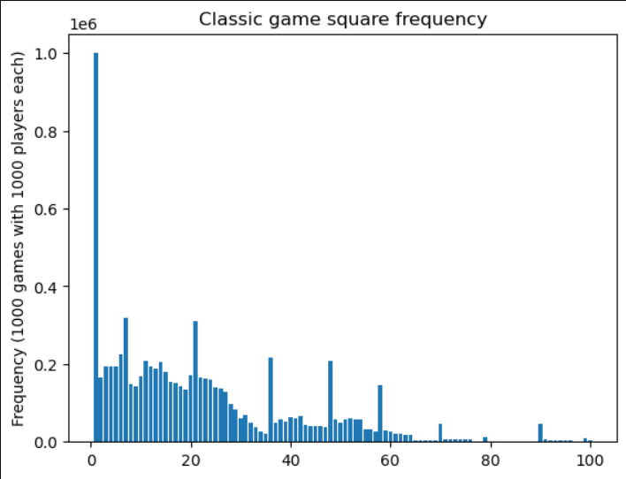
- The plan:
  - Plot the square frequencies for the other games by tomorrow (20/03), possibly doing relative square frequencies instead.
  - Try to work on analysis of game length afterwards, possibly requiring modification of SnakesAndLadders class.

20/03/26
- Changed number of player and turns in cell 6 of the analysis code to make results closer to typical cases, as well as changed comments:
Cell 6
# Shared variables
numplyrs = 1
numtms = 10000
mxtrns = 100
Vrbsty = 'none'

# Stores list logging each player's squares for each turn of each game, as well as display the time to run them (~4s-10s each with similar computer
# performance and settings (numplyrs = 1, numtms = 10000, mxtrns = 100))
startTime = time.time() # Time before games are ran

- Split cell 8 into two so that square frequency calculation could be ran separately from plotting, as well as calculating relative square frequencies (per game and per player) and created plots for the other two games, among other changes:
Cell 7 (Markdown)
# Analyse results
## 1. Square frequency
### 1.1. Square frequency generation

Cell 8
[…]
# Find square frequencies of played games, as well as shows the time taken to calculate them (~6-15s each with similar computer performance and
# settings (numplyrs = 1, numtms = 10000, mxtrns = 100))
startTime_squareFreq = time.time() # Time before games are ran

# Classic game square frequency
squareFreq_c = get_square_frequency(gamesList=gl_c, numSquares=numsqrs)
totalTime_squareFreq_c = time.time() # Time after classic game square frequency calculation
time_squareFreq_c = totalTime_squareFreq_c - startTime_squareFreq # Classic game square frequency calculation running time
print(f"Classic game square freq. calc. running time: {time_squareFreq_c} s")

# Rollover game square frequency
squareFreq_r = get_square_frequency(gamesList=gl_r, numSquares=numsqrs)
totalTime_squareFreq_r = time.time() # Time after classic and rollover games' square frequency calculation
time_squareFreq_r = totalTime_squareFreq_r - totalTime_squareFreq_c # Rollover game square frequency calculation running time
print(f"Rollover game square freq. calc. running time: {time_squareFreq_r} s")

# Ignore game square frequency
squareFreq_i = get_square_frequency(gamesList=gl_i, numSquares=numsqrs)
totalTime_squareFreq_i = time.time() # Time after classic, rollover and ignore games' square frequency calculation
time_squareFreq_i = totalTime_squareFreq_i - totalTime_squareFreq_r # Ignore game square frequency calculation running time
print(f"Ignore game square freq. calc. running time: {time_squareFreq_i} s")

Cell 9 (Markdown)
### 1.2. Relative frequency plots

Cell 10
# Gets square numbers and square frequency numbers in separate variables for later graphs
squareNums = list(squareFreq_c.keys()) # Converted from dictionary view to list

squareFreqNums_c = list(squareFreq_c.values())
squareFreqNums_r = list(squareFreq_r.values())
squareFreqNums_i = list(squareFreq_i.values())

# Calculates relative square frequency (per player and per game)
relSquareFreqNums_c = np.array(squareFreqNums_c)/(numtms*numplyrs) # Converted into a NumPy array to allow for division
relSquareFreqNums_r = np.array(squareFreqNums_r)/(numtms*numplyrs)
relSquareFreqNums_i = np.array(squareFreqNums_i)/(numtms*numplyrs)

# Plots relative square frequencies as bar graphs

# Classic game bar graph
fig, ax = plt.subplots()
ax.bar(squareNums, relSquareFreqNums_c)
ax.set_ylabel(f'Relative square frequency')
ax.set_title('Classic game relative frequency')
plt.show()

# Rollover game bar graph
fig, ax = plt.subplots()
ax.bar(squareNums, relSquareFreqNums_r)
ax.set_ylabel(f'Relative square frequency')
ax.set_title('Rollover game relative frequency')
plt.show()

# Ignore game bar graph
fig, ax = plt.subplots()
ax.bar(squareNums, relSquareFreqNums_i)
ax.set_ylabel(f'Relative square frequency')
ax.set_title('Ignore game relative frequency')
plt.show()

  - Plots for the relative frequencies:
    - 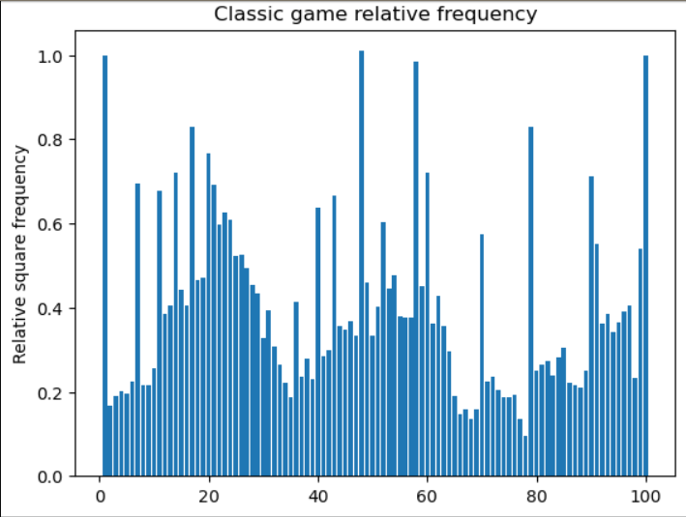
    - 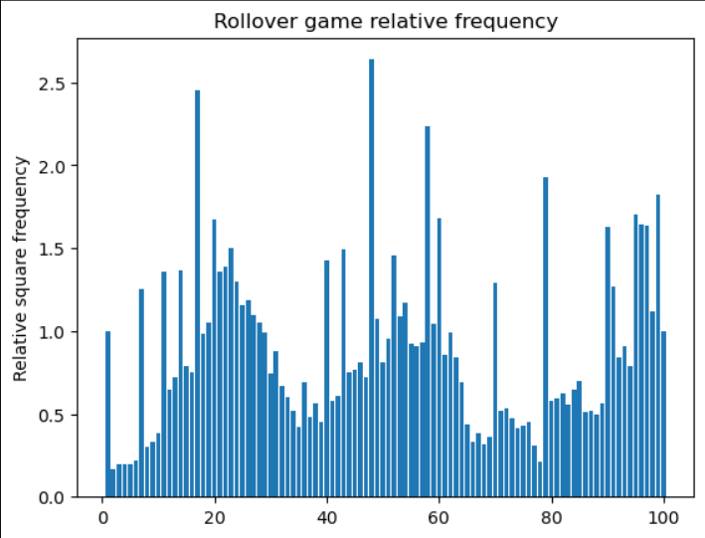
    - 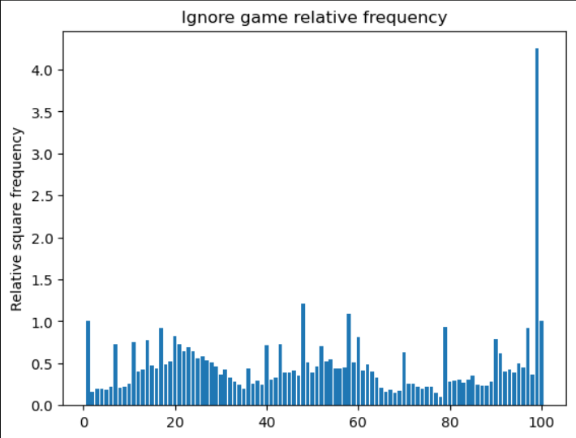
- The plan:
  - Work on analysis of game length possibly requiring modification of SnakesAndLadders class by Sunday (22/03).

22/03/26
- Modified cell 10 so that the graphs have x labels, as well as changed y labels and titles for clarity:
Cell 10
[…]
# Classic game bar graph
fig, ax = plt.subplots()
ax.bar(squareNums, relSquareFreqNums_c)
ax.set_xlabel('Square number')
ax.set_ylabel('Relative frequency (per game and per player)')
ax.set_title('Classic game relative square frequency')
plt.show()

# Rollover game bar graph
fig, ax = plt.subplots()
ax.bar(squareNums, relSquareFreqNums_r)
ax.set_xlabel('Square number')
ax.set_ylabel('Relative frequency (per game and per player)')
ax.set_title('Rollover game relative square frequency')
plt.show()

# Ignore game bar graph
fig, ax = plt.subplots()
ax.bar(squareNums, relSquareFreqNums_i)
ax.set_xlabel('Square number')
ax.set_ylabel('Relative frequency (per game and per player)')
ax.set_title('Ignore game relative square frequency')
plt.show()

  - The plots:
    - 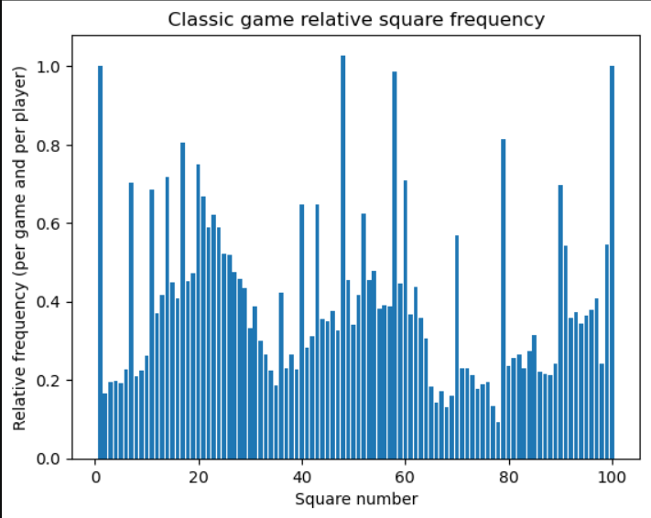
    - 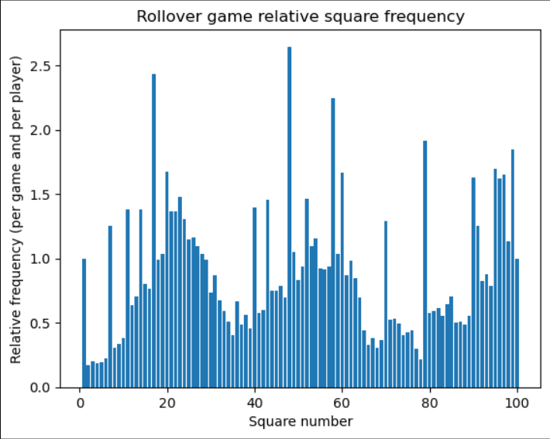
    - 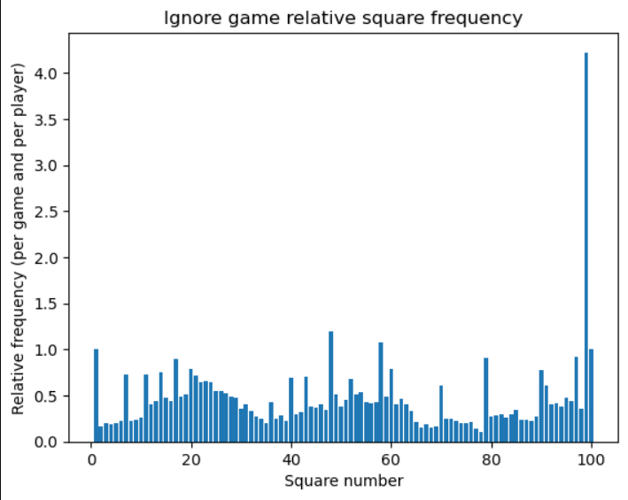
- Also written code for analysing game lengths, without changing the class code yet:
Cell 11 (Markdown)
## 2. Game length
### Game length calculation

Cell 12
def get_game_lengths(gamesList):
''' Gets the number of turns each game lasts in a games list.

Inputs:
gamesList: The list with the arrays containing the square numbers each player were on in each turn in a game, starting from the zeroth turn at
square 1. For each game array, the rows are the players and the columns are the turns.

Outputs:
gameLengths: A list of game lengths, ordered by the games in the original game length.
'''

## Predefines game lengths list for later loop
gameLengths = []

## Game lengths list loop
for game in gamesList:
### gets length (number of turns) in the game
gameShape = np.shape(game)
length = gameShape[1]

### Adds game length to game lengths list
gameLengths.append(length)

return gameLengths

# Test for get_square_frequency
gl_test2 = [np.array([[1,2,3],[4,5,6]]), np.array([[7,8,9,10],[1,2,3,4]]), np.array([[5],[6]])]
#print(gl_test2)
squareFreq_test2 = get_game_lengths(gamesList=gl_test2)
#print(squareFreq_test2)

# Find square frequencies of played games, as well as shows the time taken to calculate them (~[_]-[_]s each with similar computer performance and
# settings (numplyrs = 1, numtms = 10000, mxtrns = 100))
startTime_gameLengths = time.time() # Time before games are ran

# Classic game lengths
gameLengths_c = get_game_lengths(gamesList=gl_c)
totalTime_gameLengths_c = time.time() # Time after classic game lengths calculation
time_gameLengths_c = totalTime_gameLengths_c - startTime_gameLengths # Classic game lengths calculation running time
print(f"Classic game lengths calc. running time: {time_gameLengths_c} s")

# Rollover game lengths
gameLengths_r = get_game_lengths(gamesList=gl_r)
totalTime_gameLengths_r = time.time() # Time after classic and rollover games' lengths calculation
time_gameLengths_r = totalTime_gameLengths_r - totalTime_gameLengths_c # Rollover game lengths calculation running time
print(f"Rollover game lengths calc. running time: {time_gameLengths_r} s")

# Ignore game lengths
gameLengths_i = get_game_lengths(gamesList=gl_i)
totalTime_gameLengths_i = time.time() # Time after classic, rollover and ignore games' lengths calculation
time_gameLengths_i = totalTime_gameLengths_i - totalTime_gameLengths_i # Ignore game lengths calculation running time
print(f"Ignore game lengths calc. running time: {time_gameLengths_i} s")

Cell 13 (Markdown)
### 1.2. Relative frequency plots

Cell 14
# Shared variable
bn = 'auto'

# Classic game histogram
fig, ax = plt.subplots()
ax.hist(gameLengths_c, bins=bn)
ax.set_xlabel('Number of turns')
ax.set_ylabel('Count')
ax.set_title('Classic game length frequency histogram')
plt.show()

# Rollover game histogram
fig, ax = plt.subplots()
ax.hist(gameLengths_r, bins=bn)
ax.set_xlabel('Number of turns')
ax.set_ylabel('Count')
ax.set_title('Rollover game length frequency histogram')
plt.show()

# Ignore game histogram
fig, ax = plt.subplots()
ax.hist(gameLengths_i, bins=bn)
ax.set_xlabel('Number of turns')
ax.set_ylabel('Count')
ax.set_title('Ignore game length frequency histogram')
plt.show()

- Plots for cell 14:
  - 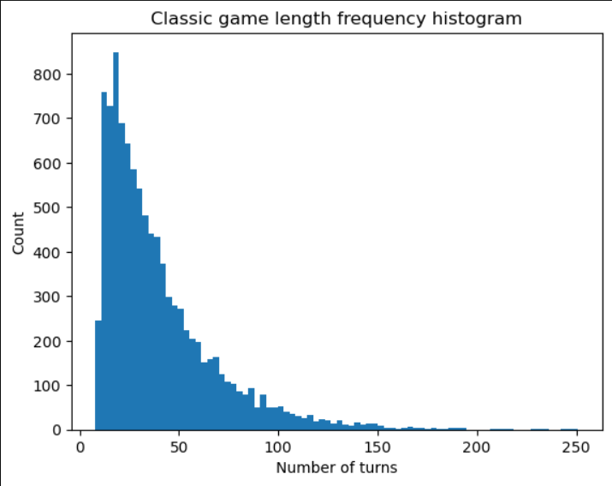
  - 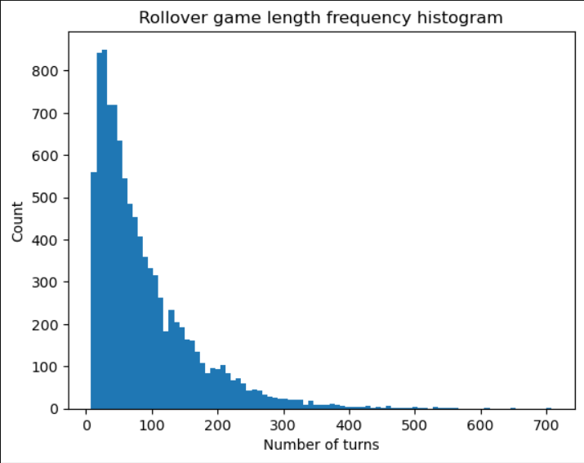
  - 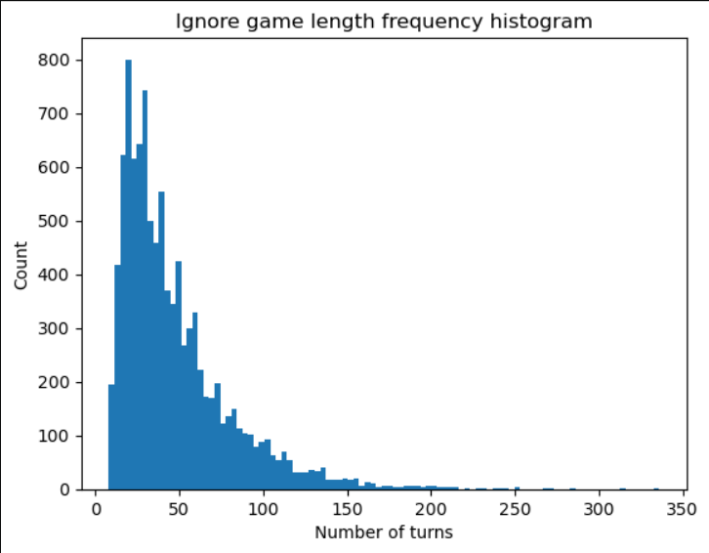
- Despite the maximum number of turns being kept at 100, there are games longer than that, implying an issue with the class code.
- The plan:
  - Fix maximum turn number code issue in the SnakesAndLadders code by tomorrow (23/03).
  - Add code to SnakesAndLadders that allows turns for player going up/down the ladder/snake to be merged with previous.

23/03/26
- In SnakesAndLadders’s play_game() method, fixed maximum turn number by adding a case to end game code block:
#### Deals with end game
if (gameEnd == True)|(turn == maxTurns):
match newVerbosity:

case 'none':
####### Flags game as ending if max turn is reached
if gameEnd == False:
gameEnd = True
  - The code used to test fix:
#### 2.2.6.5 Verbosity and maxTurns test
print("\n \t \t","Verbosity and maxTurns test")
slg2_2_6_5_1= SnakesAndLadders(numSquares=10, Snakes=[[9,2],[7,5]], Ladders=[[3,8],[4,6]], Overflow='classic')

gl2_2_6_5_1 = slg2_2_6_5_1.play_game(numPlayers=1, numTimes=1, maxTurns=1, Verbosity='none')
print(f"\n Game List (Verbosity='none', maxTurns=1): {gl2_2_6_5_1}")
  - The problem may explain performance issues with the analysis code, as the generated games list were much longer than intended.
- Also added code to the play_game() method to merge snake/ladder turn with previous by adding a new parameter called sepSLturns:
def play_game(self, numPlayers, numTimes, maxTurns=100, Verbosity='full', sepSLturns=True):
'''Plays Snakes and Ladder game a specified number of times.

Inputs:
numPlayers: the number of players for the game.
numTimes: the number of times to play the game.
maxTurns: the maximum number of turns before the game ends automatically.
Verbosity: the amount of messages about the game to show the user. 'full': shows the square for each player for each turn; 'reduced': only shows a summary including the number of turns, the winner and the final square of the other players at the end of the game; 'none': shows no messages about the game, only showing warning/error messages
sepSLturns: True if going up a ladder/down a snake is considered to be a separate turn from originally moving to the square, False if they are merged together.

Outputs:
gamesList: the list of arrays containing the square number of each player for each turn of a game (starting from the zeroth turn).
'''

#### Turn loop
for j in range(0,numPlayers):
player = j + 1
prevNum = int(gameSqrNums[j,turn-1]) ##### The previous turn's square number for the player, converted from numpy.float64 to integers
prevSqr = self.Squares[prevNum-1] ##### The Square class with the corresponding previous number

##### Messages for reaching a snake/ladder (full verbosity only), included with later merged turn code on off-chance that first square has a ladder
match newVerbosity:
case 'full':
if prevSqr.hasSnake == True:
print(f"Player {player} went down the snake at square {prevNum}.")
elif prevSqr.hasLadder == True:
print(f"Player {player} went up the ladder at square {prevNum}.")

currNum = prevSqr.roll_die() ##### The current turn's (rolled) square number for the player

##### For merged Snake and Ladder turn
if sepSLturns == False:
newPrevSqr = self.Squares[currNum-1] ###### The Square class with the corresponding current number
newPrevNum = newPrevSqr.squareNum ###### Square number for display in the messages below

###### Messages for reaching a snake/ladder (full verbosity only)
match newVerbosity:
case 'full':
if newPrevSqr.hasSnake == True:
print(f"Player {player} went down the snake at square {newPrevNum}.")
elif newPrevSqr.hasLadder == True:
print(f"Player {player} went up the ladder at square {newPrevNum}.")

###### Merges turn by rolling new square if current has snake/ladder
if (newPrevSqr.hasSnake == True)|(newPrevSqr.hasLadder == True):
currNum = newPrevSqr.roll_die() ####### The new current turn's (rolled) square number for the player
  - Code for testing the above:
#### 2.2.7 sepSLturns test
print("\n \t","sepSLturns test")
slg2_2_7_1= SnakesAndLadders(numSquares=10, Snakes=[[9,2],[7,5]], Ladders=[[3,8],[4,6]], Overflow='rollback')

gl2_2_7_1 = slg2_2_7_1.play_game(numPlayers=1, numTimes=1, maxTurns=100, sepSLturns=False)
print(f"\n Game List (sepSLturns = False): {gl2_2_7_1}")
- Also made some changes to the analysis code, mainly by making the game length analysis use games that don’t separate the snake/ladder turn:
Cell 5 (Markdown)
# Analyse Results
## 1. Square Frequency
### 1.1. Play Games (with separate snake/ladder turns)

Cell 6
# Shared variables
numplyrs = 1
numtms = 10000
mxtrns = 100
Vrbsty = 'none'

# Stores list logging each player's squares for each turn of each game, as well as display the time to run them (~4s-10s each with similar computer
# performance and settings (numplyrs = 1, numtms = 10000, mxtrns = 100))
startTime = time.time() # Time before games are ran

# Classic game (overflows (rolled squares greater than the last) count as last square)
gl_c = slg_c.play_game(numPlayers=numplyrs, numTimes=numtms, maxTurns=mxtrns, Verbosity=Vrbsty, sepSLturns=True)
totalTime_gl_c = time.time() # Time after classic game
time_gl_c = totalTime_gl_c - startTime # Classic game running time
print(f"Classic game running time: {time_gl_c} s")

# Rollover game (overflows are subtracted from last square)
gl_r = slg_r.play_game(numPlayers=numplyrs, numTimes=numtms, maxTurns=mxtrns, Verbosity=Vrbsty, sepSLturns=True)
totalTime_gl_r = time.time() # Time after classic and rollover games
time_gl_r = totalTime_gl_r - totalTime_gl_c # Rollover game running time
print(f"Rollover game running time: {time_gl_r} s")

# Ignore game (overflows aren't counted, so the turn is skipped)
gl_i = slg_i.play_game(numPlayers=numplyrs, numTimes=numtms, maxTurns=mxtrns, Verbosity=Vrbsty, sepSLturns=True)
totalTime_gl_i = time.time() # Time after classic, rollover and ignore games
time_gl_i = totalTime_gl_i - totalTime_gl_r # Ignore game running time
print(f"Ignore game running time: {time_gl_i} s")

Cell 7 (Markdown)
### 1.2. Square frequency generation

Cell 9 (Markdown)
### 1.3. Relative frequency plots

Cell 11 (Markdown)
## 2. Game length
### 2.1. Play Games (without separate snake/ladder turns)

Cell 12
# Shared variables
numplyrs = 1
numtms = 10000
mxtrns = 1000
Vrbsty = 'none'

# Stores list logging each player's squares for each turn of each game, as well as display the time to run them (~4s-10s each with similar computer
# performance and settings (numplyrs = 1, numtms = 10000, mxtrns = 100))
startTime2 = time.time() # Time before games are ran

# Classic game (overflows (rolled squares greater than the last) count as last square)
gl_c2 = slg_c.play_game(numPlayers=numplyrs, numTimes=numtms, maxTurns=mxtrns, Verbosity=Vrbsty, sepSLturns=False)
totalTime_gl_c2 = time.time() # Time after classic game
time_gl_c2 = totalTime_gl_c2 - startTime2 # Classic game running time
print(f"Classic game running time: {time_gl_c2} s")

# Rollover game (overflows are subtracted from last square)
gl_r2 = slg_r.play_game(numPlayers=numplyrs, numTimes=numtms, maxTurns=mxtrns, Verbosity=Vrbsty, sepSLturns=False)
totalTime_gl_r2 = time.time() # Time after classic and rollover games
time_gl_r2 = totalTime_gl_r2 - totalTime_gl_c2 # Rollover game running time
print(f"Rollover game running time: {time_gl_r2} s")

# Ignore game (overflows aren't counted, so the turn is skipped)
gl_i2 = slg_i.play_game(numPlayers=numplyrs, numTimes=numtms, maxTurns=mxtrns, Verbosity=Vrbsty, sepSLturns=False)
totalTime_gl_i2 = time.time() # Time after classic, rollover and ignore games
time_gl_i2 = totalTime_gl_i2 - totalTime_gl_r2 # Ignore game running time
print(f"Ignore game running time: {time_gl_i2} s")

Cell 13 (Markdown)
### 2.2 Game length calculation

Cell 14
def get_game_lengths(gamesList):
''' Gets the number of turns each game lasts in a games list.

Inputs:
gamesList: The list with the arrays containing the square numbers each player were on in each turn in a game, starting from the zeroth turn at
square 1. For each game array, the rows are the players and the columns are the turns.

Outputs:
gameLengths: A list of game lengths, ordered by the games in the original game length.
'''

## Predefines game lengths list for later loop
gameLengths = []

## Game lengths list loop
for game in gamesList:
### gets length (number of turns) in the game
gameShape = np.shape(game)
length = gameShape[1] - 1 # Subtracted by one to account for 'zeroth' turn at square 1

### Adds game length to game lengths list
gameLengths.append(length)

return gameLengths

# Test for get_square_frequency
gl_test2 = [np.array([[1,2,3],[4,5,6]]), np.array([[7,8,9,10],[1,2,3,4]]), np.array([[5],[6]])]
#print(gl_test2)
squareFreq_test2 = get_game_lengths(gamesList=gl_test2)
#print(squareFreq_test2)

# Find square frequencies of played games, as well as shows the time taken to calculate them (negligible time with similar computer performance and
# settings (numplyrs = 1, numtms = 10000, mxtrns = 1000))
startTime_gameLengths = time.time() # Time before games are ran

# Classic game lengths
gameLengths_c = get_game_lengths(gamesList=gl_c2)
totalTime_gameLengths_c = time.time() # Time after classic game lengths calculation
time_gameLengths_c = totalTime_gameLengths_c - startTime_gameLengths # Classic game lengths calculation running time
print(f"Classic game lengths calc. running time: {time_gameLengths_c} s")

# Rollover game lengths
gameLengths_r = get_game_lengths(gamesList=gl_r2)
totalTime_gameLengths_r = time.time() # Time after classic and rollover games' lengths calculation
time_gameLengths_r = totalTime_gameLengths_r - totalTime_gameLengths_c # Rollover game lengths calculation running time
print(f"Rollover game lengths calc. running time: {time_gameLengths_r} s")

# Ignore game lengths
gameLengths_i = get_game_lengths(gamesList=gl_i2)
totalTime_gameLengths_i = time.time() # Time after classic, rollover and ignore games' lengths calculation
time_gameLengths_i = totalTime_gameLengths_i - totalTime_gameLengths_i # Ignore game lengths calculation running time
print(f"Ignore game lengths calc. running time: {time_gameLengths_i} s")

Cell 15 (Markdown)
### 2.3. Game Length plots

  - Cell 12 raises IndexError: list index out of range for line 254 (of class code): newPrevSqr = self.Squares[currNum-1]
- The plan:
  - Solve IndexError tomorrow (24/03).

24/03/26
- Fixed the previous IndexError in SnakesAndLadders’s play_game() method by moving merged snake/ladder code block after special currNum block:
#### Turn loop
for j in range(0,numPlayers):
player = j + 1
prevNum = int(gameSqrNums[j,turn-1]) ##### The previous turn's square number for the player, converted from numpy.float64 to integers
prevSqr = self.Squares[prevNum-1] ##### The Square class with the corresponding previous number

##### Messages for reaching a snake/ladder (full verbosity only), included with later merged turn code on off-chance that first square has a ladder
match newVerbosity:
case 'full':
if prevSqr.hasSnake == True:
print(f"Player {player} went down the snake at square {prevNum}.")
elif prevSqr.hasLadder == True:
print(f"Player {player} went up the ladder at square {prevNum}.")

currNum = prevSqr.roll_die() ##### The current turn's (rolled) square number for the player

##### Special cases of currNum
if (currNum == self.numSquares)|(currNum == False): ##### Player reaches the last square
gameEnd = True

###### Makes sure that this is the first valid winner
if firstWinner == True:
winner = player
firstWinner = False
elif currNum > self.numSquares: ##### Player rolls a higher square than the last (if possible)

match self.Overflow:
###### case 'rollback' was already dealt with by generated square numbers

case 'classic':
currNum = self.numSquares
gameEnd = True

######## Makes sure that this is the first valid winner
if firstWinner == True:
winner = player
firstWinner = False
case 'ignore':
######## Shows message for full verbosity only
match newVerbosity:
case 'full':
print(f"Player {player}'s roll ({currNum}) was too big.")

currNum = int(gameSqrNums[j,turn-1]) ######## Use previous turn's square number, with the number converted to int as it produces numpy.float64 type, which is invalid for indexing

##### For merged Snake and Ladder turn
if sepSLturns == False:
newPrevSqr = self.Squares[currNum-1] ###### The Square class with the corresponding current number
newPrevNum = newPrevSqr.squareNum ###### Square number for display in the messages below

###### Messages for reaching a snake/ladder (full verbosity only)
match newVerbosity:
case 'full':
if newPrevSqr.hasSnake == True:
print(f"Player {player} went down the snake at square {newPrevNum}.")
elif newPrevSqr.hasLadder == True:
print(f"Player {player} went up the ladder at square {newPrevNum}.")

###### Merges turn by rolling new square if current has snake/ladder
if (newPrevSqr.hasSnake == True)|(newPrevSqr.hasLadder == True):
currNum = newPrevSqr.roll_die() ####### The new current turn's (rolled) square number for the player
  - The issue was found to be due to currNum having values larger than the number of squares in the board, which was previously dealt with in the code block after the merged snake/ladder block.
  - Also converted ‘ignore’ case’s currNum assignment to int for reasons explained in the relevant comment.
- Also made some changes to analysis code, mostly assigning sepSLturns parameters in play_game() methods with a shared variable for convenience, creating shared variables for the plots and changing comments for code running time:
Cell 6
# Shared variables
numplyrs = 1
numtms = 10000
mxtrns = 100
Vrbsty = 'none'
spTrns = True

# Stores list logging each player's squares for each turn of each game, as well as display the time to run them (~4-8s each with similar computer
# performance and settings (numplyrs = 1, numtms = 10000, mxtrns = 100))
startTime = time.time() # Time before games are ran

# Classic game (overflows (rolled squares greater than the last) count as last square)
gl_c = slg_c.play_game(numPlayers=numplyrs, numTimes=numtms, maxTurns=mxtrns, Verbosity=Vrbsty, sepSLturns=spTrns)
totalTime_gl_c = time.time() # Time after classic game
time_gl_c = totalTime_gl_c - startTime # Classic game running time
print(f"Classic game running time: {time_gl_c} s")

# Rollover game (overflows are subtracted from last square)
gl_r = slg_r.play_game(numPlayers=numplyrs, numTimes=numtms, maxTurns=mxtrns, Verbosity=Vrbsty, sepSLturns=spTrns)
totalTime_gl_r = time.time() # Time after classic and rollover games
time_gl_r = totalTime_gl_r - totalTime_gl_c # Rollover game running time
print(f"Rollover game running time: {time_gl_r} s")

# Ignore game (overflows aren't counted, so the turn is skipped)
gl_i = slg_i.play_game(numPlayers=numplyrs, numTimes=numtms, maxTurns=mxtrns, Verbosity=Vrbsty, sepSLturns=spTrns)
totalTime_gl_i = time.time() # Time after classic, rollover and ignore games
time_gl_i = totalTime_gl_i - totalTime_gl_r # Ignore game running time
print(f"Ignore game running time: {time_gl_i} s")

Cell 8
[…]
# Find square frequencies of played games, as well as shows the time taken to calculate them (~6-12s each with similar computer performance and
# settings (numplyrs = 1, numtms = 10000, mxtrns = 100))
[...]

Cell 10
[…]
# Plots relative square frequencies as bar graphs

# Shared variables
xLbl = 'Square number'
yLbl = 'Relative frequency (per game and per player)'

# Classic game bar graph
fig, ax = plt.subplots()
ax.bar(squareNums, relSquareFreqNums_c)
ax.set_xlabel(xLbl)
ax.set_ylabel(yLbl)
ax.set_title('Classic game relative square frequency')
plt.show()

# Rollover game bar graph
fig, ax = plt.subplots()
ax.bar(squareNums, relSquareFreqNums_r)
ax.set_xlabel(xLbl)
ax.set_ylabel(yLbl)
ax.set_title('Rollover game relative square frequency')
plt.show()

# Ignore game bar graph
fig, ax = plt.subplots()
ax.bar(squareNums, relSquareFreqNums_i)
ax.set_xlabel(xLbl)
ax.set_ylabel(yLbl)
ax.set_title('Ignore game relative square frequency')
plt.show()

Cell 12
# Shared variables
numplyrs = 1
numtms = 10000
mxtrns = 1000
Vrbsty = 'none'
spTrns = False

# Stores list logging each player's squares for each turn of each game, as well as display the time to run them (~4-9s each with similar computer
# performance and settings (numplyrs = 1, numtms = 10000, mxtrns = 100))
startTime2 = time.time() # Time before games are ran

# Classic game (overflows (rolled squares greater than the last) count as last square)
gl_c2 = slg_c.play_game(numPlayers=numplyrs, numTimes=numtms, maxTurns=mxtrns, Verbosity=Vrbsty, sepSLturns=spTrns)
totalTime_gl_c2 = time.time() # Time after classic game
time_gl_c2 = totalTime_gl_c2 - startTime2 # Classic game running time
print(f"Classic game running time: {time_gl_c2} s")

# Rollover game (overflows are subtracted from last square)
gl_r2 = slg_r.play_game(numPlayers=numplyrs, numTimes=numtms, maxTurns=mxtrns, Verbosity=Vrbsty, sepSLturns=spTrns)
totalTime_gl_r2 = time.time() # Time after classic and rollover games
time_gl_r2 = totalTime_gl_r2 - totalTime_gl_c2 # Rollover game running time
print(f"Rollover game running time: {time_gl_r2} s")

# Ignore game (overflows aren't counted, so the turn is skipped)
gl_i2 = slg_i.play_game(numPlayers=numplyrs, numTimes=numtms, maxTurns=mxtrns, Verbosity=Vrbsty, sepSLturns=spTrns)
totalTime_gl_i2 = time.time() # Time after classic, rollover and ignore games
time_gl_i2 = totalTime_gl_i2 - totalTime_gl_r2 # Ignore game running time
print(f"Ignore game running time: {time_gl_i2} s")

Cell 16
# Shared variable
bn = 'auto'
dnsty = False # Whether the histograms show probability densities
xLbl = 'Number of turns'
yLbl = 'Count'

# Classic game histogram
fig, ax = plt.subplots()
ax.hist(gameLengths_c, bins=bn, density=dnsty)
ax.set_xlabel(xLbl)
ax.set_ylabel(yLbl)
ax.set_title('Classic game length histogram')
plt.show()

# Rollover game histogram
fig, ax = plt.subplots()
ax.hist(gameLengths_r, bins=bn, density=dnsty)
ax.set_xlabel(xLbl)
ax.set_ylabel(yLbl)
ax.set_title('Rollover game length histogram')
plt.show()

# Ignore game histogram
fig, ax = plt.subplots()
ax.hist(gameLengths_i, bins=bn, density=dnsty)
ax.set_xlabel(xLbl)
ax.set_ylabel(yLbl)
ax.set_title('Ignore game length histogram')
plt.show()

- The plan:
  - Add analysis code and other changes to GitHub by tomorrow (25/03).
  - Find a way to optimise code to improve performance [optional].
  - Find a way to save analysis images automatically [optional].

25/03/26
- Added new/updated files to GitHub, as well as updated README.md:
  - 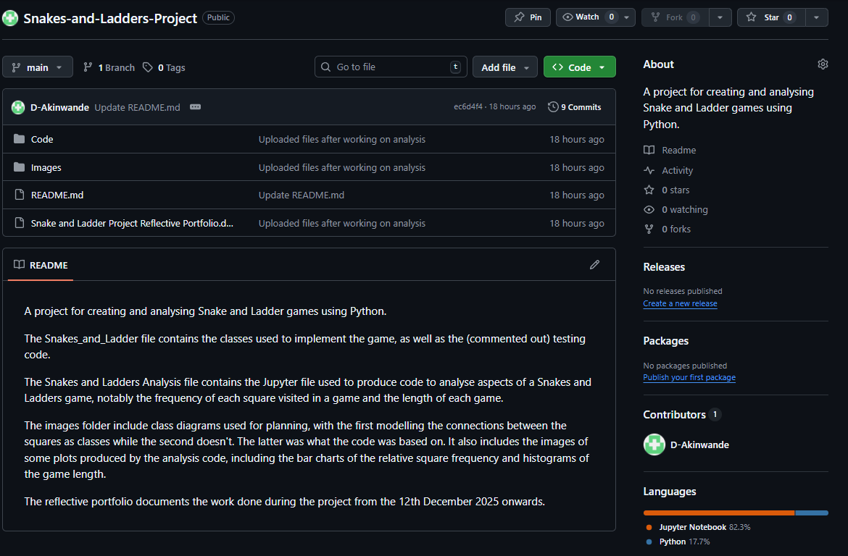
- The plan:
  - Update, then upload, analysis code to use more games for game length analysis for better looking plots.

26/03/26
- Made some changes to the analysis code, most notably making the game length histograms into probability distributions:
Cell 2:
import numpy as np
import types as tp
import time
import matplotlib.pyplot as plt
from scipy import stats

from Snakes_and_Ladders import SnakesAndLadders as SL

Cell 4
# Shared variables
numsqrs = 100
snks = [[29,7],[38,20],[44,14],[55,11],[62,40],[73,52],[82,60],[93,43],[96,17],[98,48]]
lddrs = [[3,21],[4,36],[15,48],[24,58],[31,70],[49,90],[60,79],[63,99],[72,91],[77,97]]

# Classic game, where overflows (rolled squares greater than the last on the board) count as the last square
slg_c = SL(numSquares=numsqrs, Snakes=snks, Ladders=lddrs, Overflow='classic')

# Rollback game, where overflows are subtracted from the last square
slg_r = SL(numSquares=numsqrs, Snakes=snks, Ladders=lddrs, Overflow='rollback')

# Ignore game, where overflows aren't counted and the turn is effectively skipped
slg_i = SL(numSquares=numsqrs, Snakes=snks, Ladders=lddrs, Overflow='ignore')

Cell 12
# Shared variables
numplyrs = 1
numtms = 100000
mxtrns = 1000
Vrbsty = 'none'
spTrns = False

# Stores list logging each player's squares for each turn of each game, as well as display the time to run them (~40-90s each with similar computer
# performance and settings (numplyrs = 1, numtms = 100000, mxtrns = 1000))
startTime2 = time.time() # Time before games are ran

# Classic game (overflows (rolled squares greater than the last) count as last square)
gl_c2 = slg_c.play_game(numPlayers=numplyrs, numTimes=numtms, maxTurns=mxtrns, Verbosity=Vrbsty, sepSLturns=spTrns)
totalTime_gl_c2 = time.time() # Time after classic game
time_gl_c2 = totalTime_gl_c2 - startTime2 # Classic game running time
print(f"Classic game running time: {time_gl_c2} s")

# Rollover game (overflows are subtracted from last square)
gl_r2 = slg_r.play_game(numPlayers=numplyrs, numTimes=numtms, maxTurns=mxtrns, Verbosity=Vrbsty, sepSLturns=spTrns)
totalTime_gl_r2 = time.time() # Time after classic and rollover games
time_gl_r2 = totalTime_gl_r2 - totalTime_gl_c2 # Rollover game running time
print(f"Rollover game running time: {time_gl_r2} s")

# Ignore game (overflows aren't counted, so the turn is skipped)
gl_i2 = slg_i.play_game(numPlayers=numplyrs, numTimes=numtms, maxTurns=mxtrns, Verbosity=Vrbsty, sepSLturns=spTrns)
totalTime_gl_i2 = time.time() # Time after classic, rollover and ignore games
time_gl_i2 = totalTime_gl_i2 - totalTime_gl_r2 # Ignore game running time
print(f"Ignore game running time: {time_gl_i2} s")

Cell 14
[…]
# Find square frequencies of played games, as well as shows the time taken to calculate them (negligible time with similar computer performance and
# settings (numplyrs = 1, numtms = 100000, mxtrns = 1000))
startTime_gameLengths = time.time() # Time before games are ran
[…]

Cell 16
# Shared variable
bn = 'auto'
dnsty = True # Whether the histograms show probability densities
xLbl = 'Number of turns'
gameName = ['Classic', 'Rollover', 'Ignore']

if dnsty == True:
yLbl = 'Probability density'
title = ' game length probability distribution'
else:
yLbl = 'Count'
title = ' game length histogram'

# Classic game histogram
fig, ax = plt.subplots()
ax.hist(gameLengths_c, bins=bn, density=dnsty)
ax.set_xlabel(xLbl)
ax.set_ylabel(yLbl)
ax.set_title(gameName[0]+title)
plt.show()

# Rollover game histogram
fig, ax = plt.subplots()
ax.hist(gameLengths_r, bins=bn, density=dnsty)
ax.set_xlabel(xLbl)
ax.set_ylabel(yLbl)
ax.set_title(gameName[1]+title)
plt.show()

# Ignore game histogram
fig, ax = plt.subplots()
ax.hist(gameLengths_i, bins=bn, density=dnsty)
ax.set_xlabel(xLbl)
ax.set_ylabel(yLbl)
ax.set_title(gameName[2]+title)
plt.show()

  - New plots for game length:
    - 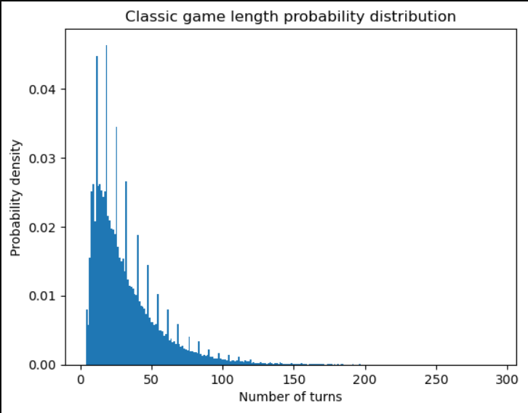
    - 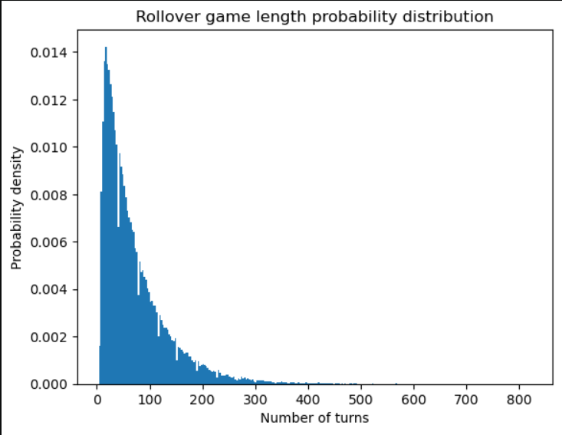
    - 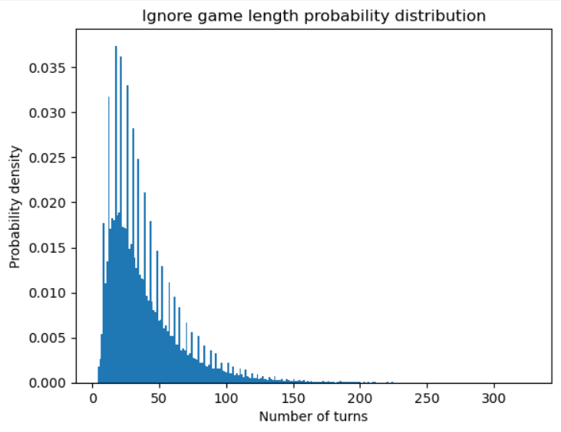

- Also added a section showing the summary statistics of the games length:
Cell 17 (Markdown)
### 2.4. Game Length Summary Statistics

Cell 18
# Classic game
median_gameLength_c = np.median(gameLengths_c)
mode_gameLengths_c = stats.mode(gameLengths_c)

print("\t Classic game summary statistics")
print(stats.describe(gameLengths_c)) # Shows several summary statistics, with nobs being the number of observations
print(f"Median: {median_gameLength_c}")
print(f"Mode: {mode_gameLengths_c}")

# Rollover game
median_gameLength_r = np.median(gameLengths_r)
mode_gameLengths_r = stats.mode(gameLengths_r)

print("\n \t Rollover game summary statistics")
print(stats.describe(gameLengths_r)) # Shows several summary statistics, with nobs being the number of observations
print(f"Median: {median_gameLength_r}")
print(f"Mode: {mode_gameLengths_r}")

# Ignore game
median_gameLength_i = np.median(gameLengths_i)
mode_gameLengths_i = stats.mode(gameLengths_i)

print("\n \t Ignore game summary statistics")
print(stats.describe(gameLengths_i)) # Shows several summary statistics, with nobs being the number of observations
print(f"Median: {median_gameLength_i}")
print(f"Mode: {mode_gameLengths_i}")

- The output:
Classic game summary statistics
DescribeResult(nobs=np.int64(100000), minmax=(np.int64(4), np.int64(292)), mean=np.float64(32.18432), variance=np.float64(588.0518266558664), skewness=np.float64(1.940335106908697), kurtosis=np.float64(5.783879871835515))
Median: 25.0
Mode: ModeResult(mode=np.int64(9), count=np.int64(3041))

Rollover game summary statistics
DescribeResult(nobs=np.int64(100000), minmax=(np.int64(4), np.int64(822)), mean=np.float64(71.29242), variance=np.float64(3927.700567549276), skewness=np.float64(2.0108800285738453), kurtosis=np.float64(6.112741780393135))
Median: 52.0
Mode: ModeResult(mode=np.int64(17), count=np.int64(1395))

Ignore game summary statistics
DescribeResult(nobs=np.int64(100000), minmax=(np.int64(4), np.int64(327)), mean=np.float64(39.0357), variance=np.float64(775.557741087411), skewness=np.float64(1.8754766141817123), kurtosis=np.float64(5.410615066749843))
Median: 31.0
Mode: ModeResult(mode=np.int64(17), count=np.int64(2445))

- The plan:
  - Change game length histograms to bar charts with each length plotted as its own bar, to see if it helps with noise/artifacts seen in plots [optional].

